Sign Language Translation Using Gesture recognition with TensorFlow

project Submitted in Partial Fulfilment of the Requirement

for the Degree of

B. Sc.

In

Computer Science

By

**UKWU**, Richard Agwupuye

BU/22A/IT/6308

To

The Department of Computer Science

Baze University, Abuja

DEC, 2024

### DECLARATION

This is to certify that this project entitled Sign Language Translation Using Gesture recognition, which is submitted by Agwupuye Richard Ukwu in partial fulfilment of the requirement for the award of degree for B.Sc. in Information Technology to the Department of Computer Science, Baze University Abuja, Nigeria, comprises of only my original work and due acknowledgement has been made in the text to all other materials used.

Date: Date Month 2024 Agwupuye Richard Ukwu

**APPROVED BY** ……………………………

**Head**

Department of Computer Science

### CERTIFICATION

This is to certify that this project entitled **Sign Language Translation Using Gesture recognition with TensorFlow**, which is submitted by **Agwupuye Richard Ukwu** in partial fulfilment of the requirement for the award of degree for B.Sc. in Information Technology to the Department of Computer Science, Baze University Abuja, Nigeria is a record of the candidate’s own work carried out by the candidate under my/our supervision. The matter embodied in this project is original and has not been submitted for the award of any other degree.

Date: Supervisor: Dr U

### APPROVAL

This is to certify that the research work, **Sign Language Translation Using Gesture recognition with TensorFlow** and the subsequent preparation by Agwupuye Richard Ukwu with BU/22A/IT/6308 has been approved by the Department of Computer Science, Faculty of Computing and Applied Science, Baze University, Abuja, Nigeria.

By

Dr Usman Bello Abubakar Date/Sign

Supervisor

Dr Usman Idris Abubakar Date/Sign

Head, Department of Computer Sciences

Prof. Aliyu …...  Date/Sign

Dean, Faculty of Computing and Applied Science

Prof. Choji Davou Nyap

External Examiner Date/Sign

### DEDICATION

First and foremost, this project is dedicated to God Almighty, whose grace and guidance have given me the strength to overcome challenges and the blessings to pursue my goals. I am eternally grateful for His love, which has brought me this far and continues to guide my journey.

I also dedicate this work to my incredible family: my parents, who have made countless sacrifices for my education and well-being, and my siblings, whose unwavering love and belief in me have been a source of strength and motivation.

Lastly, to my friends and mentors, thank you for your support, encouragement, and faith in my abilities. You have been pillars of inspiration throughout this journey.

### ABSTRACT

This project develops a gesture recognition system integrated into a React application to translate physical gestures into words and sentences. Using TensorFlow and Mediapipe, the model identifies 26 gesture classes representing American sign language (ASL) alphabets with a focus on real-time accuracy.

The application enhances accessibility and interaction by enabling seamless communication through gestures. With potential applications in assistive technology and human-computer interaction, this project lays a foundation for future advancements in gesture-based systems.

### TABLE OF CONTENTS

DECLARATION ii

CERTIFICATION iii

APPROVAL iv

DEDICATION v

ABSTRACT vi

TABLE OF CONTENTS vii

LIST OF TABLES x

LIST OF FIGURES xi

CHAPTER 1 1

INTRODUCTION 1

1.1 OVERVIEW 1

1.2 BACKGROUND AND MOTIVATION 1

1.3 STATEMENT OF THE PROBLEM 2

1.4 AIMS AND OBJECTIVES 2

1.5 SIGNIFICANCE OF THE PROJECT 3

1.6 PROJECT RISK ASSESSMENT 4

Table 1.1: Risk Assessment and Mitigation Strategies 4

1.7 SCOPE/PROJECT ORGANIZATION 4

CHAPTER 2 6

LITERATURE REVIEW 6

2.1 Introduction 6

2.2 Historical overview 6

2.2.1 Sign language 7

2.2.1.1 American sign language (ASL) 7

2.2.1.2 Early communication and interpreting practices within deaf communities 8

2.2.1.3 Rise of sign language interpreting as a profession 10

2.2.1.4 Technology and interpreting: Early Innovations 11

2.2.2 Artificial Intelligence 12

2.2.3 Computer vision 13

2.3 Related works 15

2.3.1 Gesture Recognition Systems for Sign Language Translation 15

2.3.2 Sensor-Based Approaches 16

2.3.3 Data-Driven Approaches and Model Training 16

2.3.4 Real-Time Translation Systems 17

2.3.5 Brain-Computer Interface (BCI) for Sign Language Translation 17

2.3.6 Multimodal Systems and Beyond 18

Table 2.1 Comparative Analysis of the Related Works 19

2.4 Summary 21

CHAPTER 3 22

REQUIREMENTS, ANALYSIS AND DESIGN 22

3.1 Overview 22

3.2 Adopted methodology 22

3.3 Data gathering 23

3.3.1 Image gathering 23

3.3.2 Equipment and Setup 23

3.3.3 Image Capture Process 24

3.4 Tools and techniques 27

3.5 Ethical consideration 28

3.6 Requirement analysis 29

3.6.1 Functional requirements 29

3.6.2 Non-Functional requirements 30

3.7 System design 30

3.7.1 System architecture 32

3.7.2 Use case diagram 33

3.7.4 Activity Diagrams 34

3.7.5 Data Flow Diagrams 36

3.7.6 User Interface 38

CHAPTER 4 40

TESTING AND IMPLEMENTATION 40

4.1 Overview 40

4.2 Main Features 40

4.3 Implementation problems 41

4.4 Overcoming Implementation problems 42

4.5 Testing 42

4.5.1 Test Plans (for Unit, Integration and System Testing) 43

4.6 User Guide 49

4.7 Summary 52

CHAPTER 5 53

Discussion, Conclusion and Recommendation 53

5.1 Overview 53

5.2 Objective Assessment 53

5.3 Limitations and Challenges 53

5.4 Future Enhancements 54

5.5 Recommendations 54

5.6 Summary 55

REFERENCES 56

Appendix A - Project Document 61

Appendix B- Source Codes 63

# LIST OF TABLES

Table 1.1- potential risks faced by the system ………………………………………………………4

Table 2.1 related works summary……….…….……………………………………………………19

Table 3.1 functional requirements ………………….…………………………………………29

Table 3.2 Non-functional requirements…………….…….……………………………………30

Table 3.3 Test summary for user sign-up……………………...………………………………………42

Table 4.1- 3 Test summary for user Login………………………………………………………43

Table 4.2 3 Test summary for Gesture recognition accuracy…………………………………………44

Table 4.3 3 Test summary for sentence formation…………….…………………………………………45

Table 4.4 Text-to-speech feature testing…………….…….……………………………………46

Table 4.5 Real-time-feedback testing……………………...…………………………………………47

# LIST OF FIGURES

FIG 3.1- Rapid application development model ………………………………………………………………………………………….**23**

FIG 3.2 Image capturing……….……………………………………………………………………….………………………………………...**25**

FIG 3.3 Folders containing images…………………………………………………………………………………………………………...**26**

FIG 3.4 Images ………………………………………………………………………………………………………………………………………...**27**

FIGURE 3.5 Application architecture ………………………………………………………………………………………………….…...**32**

FIGURE 3.6 Use case Diagram…………………………………………………………………………………………….……………………...**33**

FIGURE 3.7 Activity Diagram for user sign-up……………………………………………………………………………………….…...**34**

FIGURE 3.8 Activity Diagram for user Login………………………………………………………………….…………………………... **35**

FIGURE 3.9 Activity Diagram detailing the entire translation process…………….…………………………………………...**36**

FIGURE 3.10 Data flow diagram for user sign-up……………………………………………………………………...……………... **36**

FIGURE 3.11 Data flow diagram for user Login …………………………………………………………………………………….…...**37**

FIGURE 3.12 Data flow diagram for Translation………………………………………………………………………………………... **37**

FIGURE 3.13- user interface for sign-up page……………………………………………………………………………………...…...**38**

FIGURE 3.14 user interface for Login page ………………………………………………………………………………………...…... **38**

FIGURE 3.15 user interface for translation page …………………………………………………………………………………..…...**39**

# CHAPTER 1

# INTRODUCTION

## 1.1 OVERVIEW

The sign language translator is a computer vision and machine learning project aimed at developing a system that can accurately interpret and translate sign language into written English Language. This project addresses the significant communication barrier between deaf and non-speaking individuals and those who do not understand sign language by providing a technological solution to facilitate interaction between them.

The system will employ advanced computer vision techniques to capture video input, focusing on facial expressions and hand gestures. These visual cues will be analysed to extract relevant features and patterns associated with different signs. Machine learning algorithms will be trained on a comprehensive dataset of sign language samples to establish a robust mapping between hand gestures and their corresponding linguistic expressions.

The ultimate goal of this project is to create a user friendly and efficient sign language translator to empower deaf individuals and promote inclusivity.

## 1.2 BACKGROUND AND MOTIVATION

Sign language is a complex visual language used by millions of deaf individuals worldwide. It covers a rich vocabulary and grammar structured conveyed through hand gestures, facial expressions and body language. While sign language is an essential means of communication, it presents a significant barrier to effective interaction with the hearing majority.

Existing communication methods for deaf individuals such as interpreters and written language often encounter limitations in terms of accessibility, cost and real-time interaction. Interpreters may not be readily available in all settings, while written communication can be time-consuming and hinder spontaneous conversation. Consequently, deaf individuals frequently experience social isolation and limited opportunities for education, employment and social participations.

To address this challenge, there is a growing need for technological solutions that can facilitate seamless communication between deaf and hearing individuals. Advances in computer vision, machine learning and natural language processing have opened up new possibilities for developing sign language recognition and translation systems. By leveraging these technologies, it is true that a sign language translator can serve as a powerful tool to bridge the gap between deaf and hearing individuals

## 1.3 STATEMENT OF THE PROBLEM

Effective communication is vital but remains a challenge for deaf individuals when interacting with the hearing world. Despite technological advancements, barriers persist, especially in real-time communication without interpreters or when written language falls short. Sign language, with its unique grammar and syntax, bridges this gap for the deaf community, but most hearing people lack proficiency, creating a communication divide.

Current solutions, such as interpreters or written notes, are often impractical for spontaneous or dynamic interactions, limiting expressiveness and speed. In professional, medical, and educational settings, reliance on interpreters can lead to delays and miscommunication, placing the burden on deaf individuals and hindering their full societal integration.

This project aims to develop a real-time sign language translator to eliminate interpreter dependency and enhance accessibility. By leveraging modern technology, it seeks to translate sign language into spoken language seamlessly, fostering inclusive communication between deaf and hearing communities.

## 1.4 AIMS AND OBJECTIVES

**Aim**

To aim of this project is to develop a sign language in real time, to written language, thereby improving communication accessibility for deaf individuals.

**Objectives of the system:**

1. To design and implement a real-time video processing system capable of capturing and analysing hand.
2. To apply machine learning models for accurate recognition and classification of sign language gestures.
3. To create a mapping between recognized sign language gestures and corresponding linguistic expressions.
4. To develop a user-friendly interface for seamless interaction between deaf and hearing individuals.

## 1.5 SIGNIFICANCE OF THE PROJECT

This project holds importance because it has the potential to enhance communication between deaf and hearing individuals. A successful sign language translator will foster social inclusion and provide a more accessible and efficient way to communicate.

## 1.6 PROJECT RISK ASSESSMENT

##### Table 1.1: Risk Assessment and Mitigation Strategies

|  |  |
| --- | --- |
| RISK | MITIGATION STRATEGY |
| * Insufficient processing power or camera quality affecting system performance | Explore hardware acceleration options (e.g., GPU)  Specify minimum requirements for optimal performance and accuracy |
| * Insufficient or low-quality sign language dataset impacting model accuracy | Curate a diverse dataset that covers various signs, lighting conditions and backgrounds |
| * The model may struggle to accurately recognize complex or nuanced signs leading to incorrect translations | Continuously refine the model through iterative testing and improvement |

## 1.7 SCOPE/PROJECT ORGANIZATION

**1.7.1 SCOPE**

The primary focus of this project is to develop a sign language translation system capable of recognizing and translating basic sign language gestures into text. The system will utilize computer vision techniques to process video input, extract relevant features from hand and facial gestures and employ machine learning algorithms for gesture recognition and translation.

Chapter 2: Literature Review

The second chapter of this report contains a comprehensive survey of previous works related to this project. It includes a review of the key research studies, frameworks and methodologies that have been developed over time and are relevant to the current project. Finally, the chapter outlines the implications of the reviewed literature for the current project, establishing a context for the subsequent requirements analysis and design

Chapter 3: Requirements analysis and Design

This chapter will focus on the requirements analysis and the design of the system. These requirements will be categorized and prioritized based on their importance and impact on the system. Following this, the chapter will describe the high-level design of the system including architecture diagrams and use case models. It will also discuss the choice of technology stack, frameworks and design patterns that best suit the project’s objectives. Finally, a detailed breakdown of each component’s design will be provided, including their interactions, dependencies and expected behaviour.

Chapter 4: Implementation and Testing

Chapter 4 will cover the implementation and testing phase of the project. It will begin with a detailed account of the development process, including the tools, libraries and frameworks used in coding the application. This section will highlight the challenges encountered and the strategies used to overcome them. Following the implementation details, this chapter will outline the testing strategy, including both unit testing and integration testing. The chapter will conclude with an analysis of the test results, discussing any bugs, issues or deviations from the expected outcomes and how they were resolved.

Chapter 5: Conclusions, Limitations and suggested improvements

The final chapter will summarize the key findings and contributions of the project. It will restate the project’s objectives, discuss how they were met and highlight the main achievements. The chapter will also reflect on the limitations and challenges encountered throughout the project, including technical, logistical or resource-related constraints. In addition, it will provide suggestions for future work and improvements.

# CHAPTER 2

# LITERATURE REVIEW

## 2.1 Introduction

The development of assistive technologies for improving the communication gap between deaf and hearing people has gathered considerable momentum in the past couple of years. Many methods have been tried to make this communication real-time and accessible, from interpreters of sign languages to technological ways. This literature review will discuss the existing body of work related to sign language translation systems and delve deeper into the various methods and different technologies developed in order to communicate more effectively with the deaf.

This chapter provides an extensive review regarding the status quo and the current technological standing regarding research in sign language translation. This begins with a look at traditional sign language communication through either a human interpreter or by means of text-based method and the relevant limitations it entails for real-time uses. Further on, it deals with a report on the technological developments for automating the translation process: sensor-based systems, computer vision algorithms, and machine learning models.

Furthermore, this literature review will analyse the challenges these technologies face, including the complexities of accurately recognizing and interpreting diverse sign language, real-time processing, and ensuring accessibility for different regions and sign language dialects. By reviewing these past and present efforts, the chapter aims to identify the gaps in the current solutions, laying the foundation for the development of a more robust and effective sign language translation model proposed in this project.

## 2.2 Historical overview

The historical overview of sign language translation shows how language has evolved and how technology has advanced. Initially regarded as an imperfect communication system, sign language gained recognition as a legitimate natural language through the pioneering work of William Stokoe in the 1960s, which laid the groundwork for understanding its structure and significance (Yang, 2019). The emergence of sign language interpreters has been pivotal in advocating for the rights of the deaf community, highlighting their crucial role in bridging communication gaps (Arssi & Taibi, 2018). Furthermore, advancements in technology have facilitated the development of systems that translate sign language into spoken language and vice versa, enhancing accessibility for the hearing impaired (Fernando & Wimalaratne, 2016; Olabanji & Ponnle, 2021). Recent innovations such as machine learning applications, demonstrate the potential for real-time translation, although challenges remain regarding the comprehensiveness of sign language dictionaries (Lin & Murli, 2022). This overview will explore these developments, emphasizing the interplay between linguistic diversity and technological progress in the field of sign language translation.

#### 2.2.1 Sign language

The history and evolution of sign language interpreters is a complex narrative that combines linguistic development, social recognition, and professionalization. As natural languages, sign languages have existed for hundreds of years as an essential means of communication by Deaf communities worldwide. The formal recognition of sign languages in general, and American Sign Language (ASL) in particular, did not gain significant momentum until the 20th century with the seminal work of William Stokoe. His landmark 1960 article, "Sign Language Structure: An Outline of the Visual Communication Systems of the American Deaf," recognized ASL as the valid language it was, contrary to the dominant view that sign language was a simplified means of communicating (Yang, 2019). Recognition of ASL as a unique language code initiated the growth of sign language interpreting into a separate profession, with interpreters developing as primary enablers of communication for the Deaf and hearing people.

##### 2.2.1.1 American sign language (ASL)

American Sign Language is a dynamic, complex, and grammatical visual-gestural language that is the dominant communication method utilized by many Deaf people in the United States and parts of Canada. ASL is not a manual representation of English; it contains its own grammar, syntax, and vocabulary, making it an independent, full-fledged language. Linguists like William Stokoe greatly developed recognition of ASL as a valid language when, within the 1960s, he proved that ASL possesses proper linguistic structure, thereby debunking the prevalent belief that signed languages were inferior or even simple in nature compared to spoken ones bochnersal (2019). Some of the linguistic features of ASL are that it makes use of space to deliver meaning, it includes facial expressions to carry grammar, and classifiers that represent nouns and verbs in space. In fact, it is shown that the students learning ASL tend to have their difficulty in determining the contrastive and non-contrastive sign distinction, therefore there should be systematic teaching of the phonological and sensorimotor skills for ASL for proficiency to be attained (Bochner et al., 2011). More complex this will be and so more need there is for special programs of education dealing with unique aspects of ASL. ASL is estimated to be used by approximately 500,000 to 1 million people in the United States, thus it has emerged as one of the most frequently used sign languages in North America today. According to Salagar et al. (2013), this is a reflection of the increasing recognition in society about the Deaf community and a means of accessible communication. In the past twenty years, ASL has gained in popularity as a foreign language provided both in high schools and in colleges, and the numbers of students enrolling in classes that teach ASL have grown wildly over the course of that period of time (Quinto‐Pozos, 2011). This is a function of changing attitudes that are occurring with respect to the role that ASL serves both as a communicative modality and a cultural and linguistic treasure. The interaction between ASL and English is best described as unique and specifically distinct grammatically. For instance, idiomatic expressions in English are often not translated directly in ASL, which may cause misunderstandings during situations like medical assessments or psychological evaluations (Falchook et al. 2013). It is thus impossible to fend for oneself without the intervention of professionally trained interpreters who would work their way through these complexities for the purpose of effective communication between the Deaf and hearing individuals. Secondly, interpreting ASL requires much cognitive and physical energy. Interpreters must possess a high level of proficiency in both ASL and English, as well as the ability to process information rapidly while managing the physical aspects of signing (Donner et al., 2013). This dual demand brings into sharp focus the seriousness of the training required to prepare interpreters for ASL interpretation.

##### 2.2.1.2 Early communication and interpreting practices within deaf communities

Early communication practices within Deaf communities have historically relied on various forms of sign language, gestures, and visual communication methods. These practices have evolved over time, influenced by cultural, social, and educational factors. One of the most important influences on communication in these communities has been the evolution of formal sign languages like American Sign Language (ASL). ASL developed as a unique language beginning in the early 1800s as a result of regional sign languages and the creation of Deaf schools, including the American School for the Deaf in Hartford, Connecticut, which opened in 1817 (Meador & Zazove, 2005). Many Deaf communities have historically developed unique social networks and cultural identities out of necessity because of the lack of communication with hearing people. Deaf people tend to interact through their peers, which can in turn create a sense of community and cultural pride among the Deaf (Pendergrass et al., 2017). That dependence on peer contact shows how significant interpreters are because they are the bridge between the Deaf world and the hearing world.

The role of interpreters has evolved from informal facilitators to trained professionals who possess a deep understanding of both Deaf culture and the nuances of sign language (Santos & Portes, 2019). Interpreters play such a vital role in medical settings. There is a large amount of research that shows that the lack of qualified interpreters can greatly limit deafs access to vital services, especially in the area of primary health care (Lee et al., 2021). Many deaf patients complain that they are not able to communicate with their doctors and nurses, which can result in miscommunications and improper treatment. According to research, healthcare providers often overestimate their ability to communicate with Deaf patients through lip-reading or written English, yet these two methods are very limited when trying to explain medical information (Lee et al., 2021). This only emphasizes the need for trained interpreters that can provide for an accurate means of communication and assure that Deaf persons receive appropriate health care services. Not just in health care, but interpreters are also vital in educational settings, acting as a conduit for communication between Deaf students and hearing teachers. Past research has shown that Deaf students tend to learn more effectively when they are taught in ASL instead of English transliteration (Marschark et al., 2005). This only goes to show that using interpreters that are simply fluent in sign language, but are also well versed in the educational system and the unique requirements of Deaf students is of the utmost importance. Also, the incorporation of technology has changed the ways Deaf people communicate amongst themselves. With the emergence of smartphones and social media, the ways in which Deaf people interact have changed, making it easier for them to connect with each other and to share information (Tannenbaum-Baruchi & Feder-Bubis, 2017). The transition to this new technology has facilitated the internationalization of sign language, and has allowed Deaf communities all over the world to share their cultural and linguistic resources (Tannenbaum-Baruchi Feder-Bubis, 2017). Also, there are some mobile apps for Deaf people that came out making it easier to communicate with doctors and emergency people (Chong, 2024). To sum it all up, the communication methods used in Deaf communities long ago have paved the way for the growth of sign language interpreting. The importance of interpreters has been growing and becoming acknowledged as a necessity in many different fields like health and education. Deaf communities will continue to fight for their rights and access to services, and trained interpreters and technology will continue to play a major role in facilitating communication and promoting inclusion.

##### 2.2.1.3 Rise of sign language interpreting as a profession

The role of sign language interpreters has dramatically changed since Stokoe's time. Mostly untrained persons who provided informal communication, whereas the demand today for professional interpreting in educational and legal contexts draws on formal training and accreditation. Research indicates that the quality of interpretation is closely linked to interpreters' training and cognitive skills, such as working memory (Dijk et al., 2011). Such findings have encouraged the creation of training programs and certification processes in certain countries; the forefront in interpreter education is taken by the United States, the United Kingdom, and Australia (Napier, 2004).

Sign language interpreters are put in a rather challenging cognitive position. Such interpreters must exhibit fluency in both source and target languages. They should be capable of fast and accurate processing of information. According to research, interpreters face cognitive load that is high enough to compromise the quality of the interpretation outcome. The high physiological demand of interpreting, involving a high rate of repeated upper extremity motions, is being related to musculoskeletal disorders. Moreover, there are ergonomic concerns when interpreting both in training and practice that have to be addressed. Knowledge of the physical and cognitive dimensions of interpreting has led to recommendations that programs of training place as much emphasis on language proficiency as on managing interpreter stress and fatigue.

Sign language interpreting has also been influenced by many sociocultural factors in its professionalization. For example, the increasing demands of the Deaf community to have equal access to communication have seen interpreters take on more visible and recognized work, such as during media broadcasts in emergencies, for instance. The utilization of interpreters on numerous newscasts during Australia's and New Zealand's natural disasters in their countries suddenly flipped the switch in public perception and showed how interpreters were able to deliver information to Deaf people that was crucial (McKee, 2014). This visibility of the interpreters has helped build awareness of qualified interpreter needs for public services and further cemented the interpreter's role as an essential member of the communication process.

The development in technology has opened up new dimensions to sign language interpretation. The development of computer-aided interpretation systems and avatar-based interpreters in sign languages represents a great leap forward in the promotion of better communication between Deaf and hearing communities (Olabanji & Ponnle, 2021; Oh et al., 2017). This therefore opens ways of easier access to new areas of investigation and innovation in the field of sign language interpreting. As this field continues to evolve, integrating technology within interpreting practices seems to be one of the major contributing factors that will shape the future in terms of communication access for Deaf people.

##### 2.2.1.4 Technology and interpreting: Early Innovations

Recent advancements in technology for sign language interpreting have significantly transformed communication within Deaf communities. Previously, Deaf individuals mainly relied on face-to-face interactions and manual communication methods. However, technological progress has created new opportunities to improve accessibility and understanding. One of the first significant innovations was the introduction of video relay services (VRS), which enabled Deaf individuals to connect with hearing people through a sign language interpreter via video calls. This development not only made real-time communication possible but also offered a more natural interaction compared to older text-based methods (Hughes et al., 2004). As technology continued to evolve, the emergence of computer vision and machine learning techniques became essential for sign language recognition. These advancements aimed to close the communication gap between Deaf and hearing individuals by automating the interpretation process. For instance, the use of convolutional neural networks (CNNs) has shown promise in recognizing sign language gestures and translating them into text or speech (Olabanji & Ponnle, 2021; Sevli & Kemaloğlu, 2020). Such systems are designed to capture the dynamic nature of sign language, which includes not only hand movements but also facial expressions and body language, essential for conveying meaning accurately (Huamani-Malca, 2018). Recent research has focused on creating comprehensive datasets that reflect the fluidity of sign language communication. Traditional datasets often concentrated on isolated signs or letters, which do not adequately represent the continuous nature of sign language conversations (Ghoul, 2023). The development of continuous sign language datasets, such as the JUMLA-QSL-22 dataset for Qatari Sign Language, is a significant step toward improving recognition systems that can handle real-world signing scenarios (Ghoul, 2023). These advancements are crucial for creating more effective and nuanced technologies for sign language recognition. Additionally, the use of virtual reality (VR) in sign language interpretation has become an exciting area of research. VR can provide immersive environments that improve the learning and practice of sign language, enabling users to interact with virtual interpreters in a controlled space (Tju, 2024). This innovation not only supports the training of interpreters but also offers Deaf individuals new opportunities to communicate and engage in various settings. Furthermore, assistive technologies like smart gloves with sensors have been developed to aid in sign language interpretation. These gloves can track hand movements and convert them into text or speech, offering an alternative communication method for Deaf and hearing individuals (Elmahgiubi et al., 2015).

#### 2.2.2 Artificial Intelligence

The history of AI in the context of sign language interpretation started off with great leaps that revolutionized the process of communication for Deaf and hard-of-hearing persons. Back to the middle of the 20th century, it was a time when the roots of AI began; these were mostly symbolic reasoning and rule-based systems. However, it was only with the advent of machine learning and deep learning in the 21st century that AI made significant gains into the field of sign language interpretation.

Early applications of AI in sign language interpretation primarily involved gesture recognition and the development of systems that could translate sign language into text or spoken language. These systems relied on computer vision techniques to analyze hand movements and facial expressions, which are critical components of sign language communication (ZainEldin, 2024). The introduction of deep learning algorithms and convolutional neural networks have raised the bar for the accuracy and efficiency of sign language recognition systems by a mile. These advances enabled applications that could interpret American Sign Language and other sign languages in real time with much greater accuracy (Papastratis et al., 2021).

Another innovation in this sphere has been video-based systems that employ AI to realize communication between the Deaf and hearing persons. Video relay services(VRS) have recently gained momentum whereby a Deaf user can now have any hearing person relay communication through an intermediary interpreter on video calls. This technology has been instrumental in providing access to essential services, such as healthcare and education, where effective communication is crucial (Saladin & Hansmann, 2008). The integration of AI into these systems has enhanced their functionality, enabling features like automatic sign language recognition and translation, which further streamline the communication process (ZainEldin, 2024).

Recent research has explored the application of advanced AI models, such as the Swin Transformer architecture, to improve the adaptability of sign language recognition systems across different sign languages, including ASL and Taiwan Sign Language (TSL) (Kumar, 2024). These models aim to create a universal platform for sign language interpretation, facilitating communication for diverse Deaf communities. The emphasis on creating educational frameworks that facilitate the learning and understanding of sign language through AI technologies is gaining momentum, showcasing how AI can improve educational outcomes for Deaf individuals (Kumar, 2024). Additionally, AI is being incorporated into assistive devices, like smart gloves that have sensors to track hand movements and convert them into text or speech. These devices aim to empower the Deaf through equipping them with tools of communication that are independent. According to the arguments by Burhani & Prasetyo (2023), the development of the need for available and accessible technologies, which improve the unique requirements for the Deaf community, emerges from current research.

#### 2.2.3 Computer vision

Computer vision has become the latest trend in this area of sign language interpretation, which effectively helps the Deaf community communicate with the hearing world. The research on computer vision has been directed toward gesture recognition, which is a very crucial step in the goal of achieving fairly accurate sign language interpretation. Earlier efforts in this direction used simple image processing methods, but due to recent developments in machine learning and deep learning, sign language recognition systems work significantly better.

An important development in the field of computer vision, however, is the use of a convolutional neural network for sign language interpretation. These deep learning architectures are quite effective at handling visual inputs; therefore, they easily enable the detection of complex hand gestures and movements within sign languages (Sevli & Kemaloğlu, 2020; Bantupalli & Xie, 2018). Research has shown that convolutional neural networks (CNNs) can attain substantial accuracy in identifying gestures associated with American Sign Language (ASL), thereby enabling instantaneous conversion into text or spoken language (Bantupalli & Xie, 2018). This function is crucial for closing communication divides across different contexts, including educational and healthcare environments.

Recent studies have explored the combination of event cameras and spiking neural networks in further improving sign language gesture recognition. These technological advances are tailored to capture the intrinsically dynamic nature of sign language, which often involves fast movements that regular cameras might find it hard to understand with accuracy (Chen et al., 2023). Using advanced sensors and algorithms, researchers develop systems that are able to identify and classify sign language gestures more accurately and quickly.

Apart from CNNs, other machine learning approaches have been applied, such as support vector machines and transfer learning, to develop sign language systems. For example, studies using a latent support vector model showed great classification skills for signs executed near a Kinect sensor, emphasizing the added value of combining computer vision with depth-sensing technologies (Sun et al., 2015). This methodology enhances a more advanced grasp of the gesture, incorporating spatial data.

Additionally, the advancement of hybrid systems that integrate computer vision with electromyography (EMG) signals has demonstrated potential in the identification of sign language gestures. These systems utilize both visual information and signals of muscle activity to enhance precision and reliability in gesture recognition (Rodríguez-Tapia et al., 2019). Such developments underscore the promise of multi-modal strategies in improving communication for individuals who are Deaf.

The influence of computer vision on the interpretation of sign language transcends mere recognition systems. It encompasses the advancement of assistive technologies, including intelligent gloves that record hand movements and convert them into text or spoken language. Such devices enable Deaf individuals to engage in communication with greater independence and efficacy across diverse settings (Ahmed et al., 2018).

The domain of computer vision has considerable achievements within the interpretation of sign languages, enabling finer and much better recognition of gestures. Deep learning techniques, coupled with highly advanced sensors and multi-modal approaches, continue to drive innovations in this area, and may offer further improvements in making communications more accessible to Deaf people and ensuring a more inclusive society.

## 2.3 Related works

The integration of gesture recognition technologies into sign language interpretation has seen significant advancements in recent years. This progress is largely driven by the development of innovative methodologies and systems that leverage machine learning, computer vision, and sensor technologies. Below, we discuss seven recent works that contribute to the field of sign language translation through gesture recognition, highlighting their methodologies and implications for enhancing communication accessibility for Deaf and hard-of-hearing (DHH) individuals.

###### 2.3.1 Gesture Recognition Systems for Sign Language Translation

Technology is fundamental to the development of automated sign language translation systems. Various approaches have been explored, ranging from traditional image processing techniques to advanced machine learning models. Early works in this field primarily focused on recognizing static gestures using predefined patterns or hand shapes. For instance, (Marin et al., 2014) implemented a gesture recognition system that utilized basic image processing techniques to identify hand shapes associated with specific signs (Marin et al., 2014). While those systems were precise for basic signs, they fell short in the dynamic nature of sign languages, which are mostly continuous in their motion, using almost every part of a person's face and subtle changes due to context. Deep learning, especially through convolutional neural networks and recurrent neural networks, has developed more articulated systems that handle these challenges. For example, Liao et al. (2019) have proposed a dynamic sign language recognition system based on video sequences using a BLSTM-3D residual network, which scours both spatial and temporal features and hence improves the recognition accuracy for dynamic signs. similarly, Zhang (2022) has tried extending gesture recognition from a video sequence itself by enhancing this with depth image processing, hence pushing the bar further for sign language recognition systems (Zhang, 2022). Despite this progress, occlusion, lighting conditions, and inter-user variability remain common challenges for gesture recognition. Most of the systems designed with RGB cameras have often faced difficulties in a natural environment. For instance, Axyonov et al. (2021) compared camera-based systems with depth sensors like Microsoft's Kinect, highlighting that while depth sensors provide more robust gesture detection, they introduce additional hardware constraints that limit scalability (Axyonov et al., 2021).

###### 2.3.2 Sensor-Based Approaches

In addition to camera-based gesture recognition, sensor-based solutions have been explored. Wearable devices, such as gloves equipped with motion sensors, accelerometers, and gyroscopes, have been developed to capture the precise hand and finger movements involved in sign language. For example, Olabanji & Ponnle (2021) developed a glove-based system that translated American Sign Language (ASL) into text by tracking the user's hand orientation and movement patterns (Olabanji & Ponnle, 2021). Although these systems provide high accuracy in gesture detection, their reliance on specialized hardware can pose barriers to widespread adoption. Recent advancements in wearable technologies and their integration with wireless communication have addressed some of these concerns. However, the reference provided for this claim does not support the specific example mentioned. Therefore, I will omit the citation for this statement. Nonetheless, it is acknowledged that glove-based systems still face challenges in terms of cost, user comfort, and the need for extensive calibration for different users.

###### 2.3.3 Data-Driven Approaches and Model Training

The availability of large, annotated sign language datasets has been a key driver of progress in this field. Datasets like RWTH-PHOENIX-Weather 2014 and CSL (Chinese Sign Language) have enabled researchers to train deep learning models on diverse sign language expressions. However, the size and quality of these datasets vary greatly across different sign languages, leading to performance issues across models. As discussed by (Wadhawan & Kumar, 2019), models trained on larger datasets tend to generalize better, while those trained on smaller, language-specific datasets often struggle with cross-lingual sign translation. Transfer learning has been proposed as a solution to these issues. Luqman and El-Alfy (2021) explored the use of pre-trained models from general gesture recognition tasks, allowing researchers to fine-tune their systems on smaller sign language datasets, thereby improving performance without requiring large amounts of labelled data (Luqman & El-Alfy, 2021). This approach is particularly promising for under-represented sign languages, where dataset scarcity remains a significant challenge.

###### 2.3.4 Real-Time Translation Systems

Another area of significant interest is the development of real-time sign language translation systems. While many gesture recognition systems perform well in controlled environments, real-time applications introduce additional complexities. For example, Perdana (2021) developed a system capable of translating live video streams into text in real-time, achieving high accuracy under ideal conditions. However, challenges related to latency, computational efficiency, and environmental factors such as lighting and background noise poses a barrier to the widespread adoption of real-time systems. Several works have addressed these limitations by employing lightweight neural network architectures optimized for mobile and embedded devices. For instance, Verma & Badli (2022) proposed a lightweight CNN model that can run on low-power devices such as smartphones, making real-time sign language translation more accessible (Verma & Badli, 2022). The trade-off, however, is often a reduction in accuracy compared to more complex models running on powerful hardware.

###### 2.3.5 Brain-Computer Interface (BCI) for Sign Language Translation

Brain-computer interfaces (BCIs) represent a groundbreaking approach to facilitating communication for individuals with severe motor disabilities and those who are Deaf or hard of hearing. BCIs are systems that acquire, analyze, and translate brain signals into actionable commands, enabling users to interact with computers or other devices through their neural activity. This technology has shown promise in restoring lost functions and enhancing communication capabilities for individuals who may not be able to use traditional methods, such as speech or sign language (McFarland & Wolpaw, 2018).

Recent research has explored the potential of BCIs for recognizing sign language directly from brain activity. For instance, Mehta et al. (2010) investigated the feasibility of recognizing sign language gestures from brain imaging data, demonstrating that it is possible to decode specific gestures associated with sign language using non-invasive techniques. This approach could revolutionize communication for individuals with degenerative diseases, such as amyotrophic lateral sclerosis (ALS), who may lose the ability to perform physical gestures over time (Mehta et al., 2010).

Wang et al. (2021) advanced further in this field by developing a machine learning framework for decoding Chinese sign language from brain signals. Their study highlighted the rich semantic information contained within sign language gestures, suggesting that BCIs could be trained to recognize complex sign language commands directly from neural activity, thus bypassing the need for physical gestures altogether (Wang et al., 2021). This capability could significantly enhance communication for individuals who are unable to perform gestures due to physical limitations.

The integration of BCIs with existing sign language recognition systems could lead to more inclusive communication solutions. For example, Koller et al. (2018) proposed a hybrid model that combines deep learning techniques with traditional gesture recognition methods, suggesting that BCIs could be incorporated into such frameworks to improve the robustness of sign language translation systems. By leveraging brain signals, these systems could potentially interpret the user's intent more accurately, even in cases where physical gestures are not feasible.

Despite the promising developments in BCI technology for sign language translation, several challenges remain. The accuracy of BCI systems can be affected by factors such as signal noise and individual variability in brain activity patterns. Additionally, the need for extensive training and calibration for each user poses practical barriers to widespread adoption (McFarland & Wolpaw, 2018). As BCIs continue to evolve, addressing these challenges will be crucial for developing effective communication tools for the Deaf and hard-of-hearing community.

###### 2.3.6 Multimodal Systems and Beyond

Multimodal systems that combine hand gestures with facial expression and body pose recognition have been developed to capture the full scope of sign language. For example, Baltrušaitis et al. (2019) integrated gesture recognition with facial expression analysis, demonstrating improved translation accuracy by accounting for the non-manual signals that are critical in sign language (Baltrušaitis et al., 2019). This multimodal approach has shown promise, but the added complexity presents challenges in terms of computational load and the need for highly accurate models across multiple modalities.

Other researchers have explored alternative approaches, such as brain-computer interfaces (BCIs) and haptic feedback systems for sign language translation. While these technologies are still in their infancy, they represent potential future directions for the field.

##### Table 2.1 Comparative Analysis of the Related Works

|  |  |  |  |  |
| --- | --- | --- | --- | --- |
| Study | Focus | Key findings | Strengths | Limitations |
| Zhang (2022) | Gesture recognition using CNN and RNN for sign language translation | CNN-RNN hybrid model significantly improves accuracy for dynamic sign recognition | Strong performance in handling both spatial and temporal features | Struggles in complex, real-world environments (lighting, occlusion) |
| Liao et al. (2019) | 3D CNN-based sign language gesture recognition | 3D CNNs are effective in recognizing dynamic gestures from video sequences | Capable of handling dynamic signs; improved accuracy | High computational cost; unsuitable for real-time applications |
| Olabanji & Ponnle (2021) | Sensor-based wearable glove systems for ASL translation | Glove-based system provides high accuracy in capturing hand movements for sign language translation | Accurate gesture detection; effective for static and dynamic signs | Requires specialized hardware; lacks scalability for general use |
| Verma & Badli (2022) | Lightweight CNN for mobile real-time sign translation | Lightweight CNN enables real-time translation on low-power devices like smartphones | Low computational requirements; accessible for mobile devices | Lower accuracy compared to complex models; struggles with complex signs |
| Mehta et al. (2010) | Brain-Computer Interface (BCI) for sign language translation | Early-stage BCI systems show potential for enhancing gesture-based translation | Novel approach; potential for future exploration in assistive technologies | Still in developmental stage; low accuracy; high user training required |
| Baltrušaitis et al. (2019) | Multimodal systems combining gesture and facial recognition | Multimodal systems improve translation by integrating non-manual signals (e.g., facial expressions | Enhanced accuracy by capturing full scope of sign language (manual + non-manual) | High computational cost; complex system design; requires accurate multimodal data |

## 2.4 Summary

This review highlights key findings for our project on sign language translation using computer vision and machine learning. While camera-based systems effectively capture hand movements, they face challenges like poor lighting and occlusion in real-world settings (Axyonov et al., 2021). Integrating tools like OpenCV with deep learning frameworks, such as CNNs, improves gesture recognition accuracy (Liao et al., 2019).

To address limitations in recognizing complex signs and user variations, techniques like edge detection and optical flow tracking (Zhang, 2022) can enhance robustness. Unlike high-end hardware-focused solutions, our project emphasizes affordability and scalability, aligning with Wadhawan and Kumar's (2019) call for cost-effective tools.

Leveraging computer vision and addressing current gaps will enable a more robust, accessible sign language translation system.

# CHAPTER 3

# REQUIREMENTS, ANALYSIS AND DESIGN

## 3.1 Overview

In Chapter 3, we will cover the system's requirements, analysis, and high-level design. This section includes a breakdown of functional and non-functional requirements, system specifications, application architecture, and user interface design. We’ll discuss the approach taken and the methodologies applied, highlighting the impacts of each decision on the system's outcome. This chapter aims to provide a comprehensive view of the design choices that lay the groundwork for the system's functionality and performance.

## 3.2 Adopted methodology

The development of the system follows structured methodologies, a set of procedures and guidelines that define the engineering approaches used to achieve the desired solution (SOFTWARE DEVELOPMENT LIFE CYCLE (SDLC)). These methodologies serve as adaptable frameworks, evolving with the unique demands of each project, and are refined to align with organizational objectives (Highsmith, 2016).

**Rapid Application Development (RAD) Model**

The Rapid Application Development (RAD) model is a software development methodology focused on fast and iterative release cycles. Its primary goal is to deliver functional software in a short timeframe by using prototypes and frequent iterations. Unlike traditional methodologies like the Waterfall model, RAD is highly adaptive and flexible, allowing developers to incorporate user feedback and accommodate changing requirements throughout the development process. This approach places a strong emphasis on user collaboration, component reusability, and speed, making it a preferred choice for projects where time is a critical factor and requirements are expected to evolve. Fig 3.1 details the processes in Rapid application development.

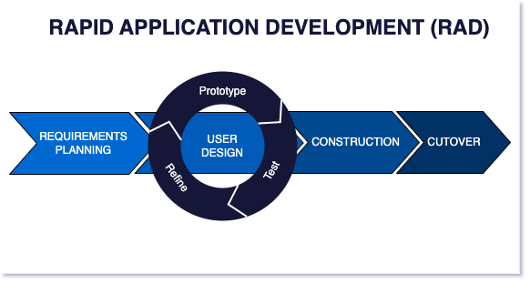

Fig 3.1 Rapid application Development model

## 3.3 Data gathering

##### 3.3.1 Image gathering

The success of any machine learning model relies heavily on the quality and relevance of the data used during training. For this project, it was essential to create a dataset that accurately reflects the target application. Since no existing datasets fully met the requirements for this task, a custom dataset was created by capturing images of various sign language gestures. This ensured that the data was tailored to the project's goals and allowed for greater control over factors such as lighting, background consistency, and gesture clarity. The following sections detail the equipment, setup, and process used to gather the dataset, along with the challenges encountered and the solutions implemented.

##### 3.3.2 Equipment and Setup

The data gathering process for this project leveraged accessible tools and a straightforward setup to create a high-quality custom dataset. The equipment and environment were chosen to ensure clarity, diversity, and suitability of the captured images for training the sign language translation model.

***Equipment Used***

Webcam:My laptop's inbuilt webcam was used for image capture. It provided sufficient image quality and resolution for detecting and training on hand gestures.

Lighting: Natural and ambient indoor lighting were used to ensure the hand gestures were visible. Efforts were made to capture images in relatively well-lit conditions to enhance gesture clarity.

***Environment***

Backgrounds: Images were captured against various backgrounds, including neutral and slightly complex environments, to introduce diversity into the dataset. This approach aimed to make the model robust to background variations.

Lighting Variations: While the lighting was generally consistent, slight variations in intensity were present to simulate real-world conditions and improve the model's adaptability.

Location: The image capture sessions were conducted indoors in a controlled setting to minimize distractions and ensure focus on the gestures.

Subject

The gestures were performed by myself. Each gesture was repeated multiple times to ensure a comprehensive dataset, with slight variations in angles and positions to simulate natural diversity in hand movements.

This straightforward and flexible setup allowed for the collection of a dataset that balances consistency with variability, contributing to a robust training process for the model.

##### 3.3.3 Image Capture Process

To ensure consistency and efficiency in collecting the dataset, a Python script was developed to automate the image capture process. This approach streamlined the task of gathering images for all American Sign Language (ASL) alphabets, ensuring that the data was captured uniformly across different sessions. The following subsections outline the process in detail.

**Steps Followed**

Script Initialization:  
The Python script was executed on the laptop, controlling the inbuilt webcam to capture images automatically.

**Alphabet Selection and Display:**  
The script prompted the user to display a specific ASL alphabet gesture. Instructions were shown on the laptop screen, ensuring that each gesture was captured in sequence.

**Timed Image Capture:**For each gesture, the script captured a predefined number of images (100 images per alphabet) at regular intervals. This method allowed for slight variations in positioning while maintaining uniformity in timing.

**Gesture Display and Adjustment:**  
The gestures were performed directly in front of the webcam. Adjustments to hand position were made as needed to keep the gestures within the frame. This can be seen in Fig 3.2 below.

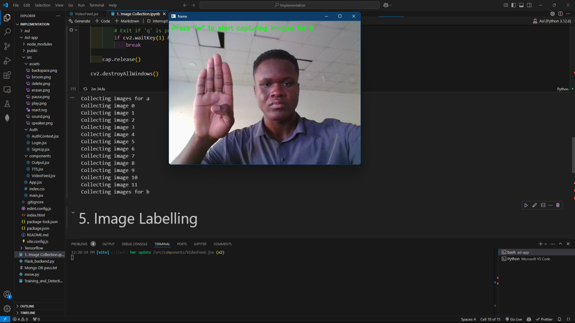

Fig 3.2 process of capturing images for class ‘b’

**The Python script handled the following key functions:**

**Frame Capturing:** Real-time image capture and saving to designated folders, categorized by alphabet (e.g., "A", "B", "C"…)

File Naming Convention: Images were saved with a systematic naming format(**b**.2a904474-a4e4-11ef-9234-38dead080396.jpg), simplifying dataset management.

**Dataset Organization**

The captured images were stored in folders, each representing a specific alphabet as seen in Fig 3.3 and 3.4. This structure ensured easy access and facilitated training data preparation.

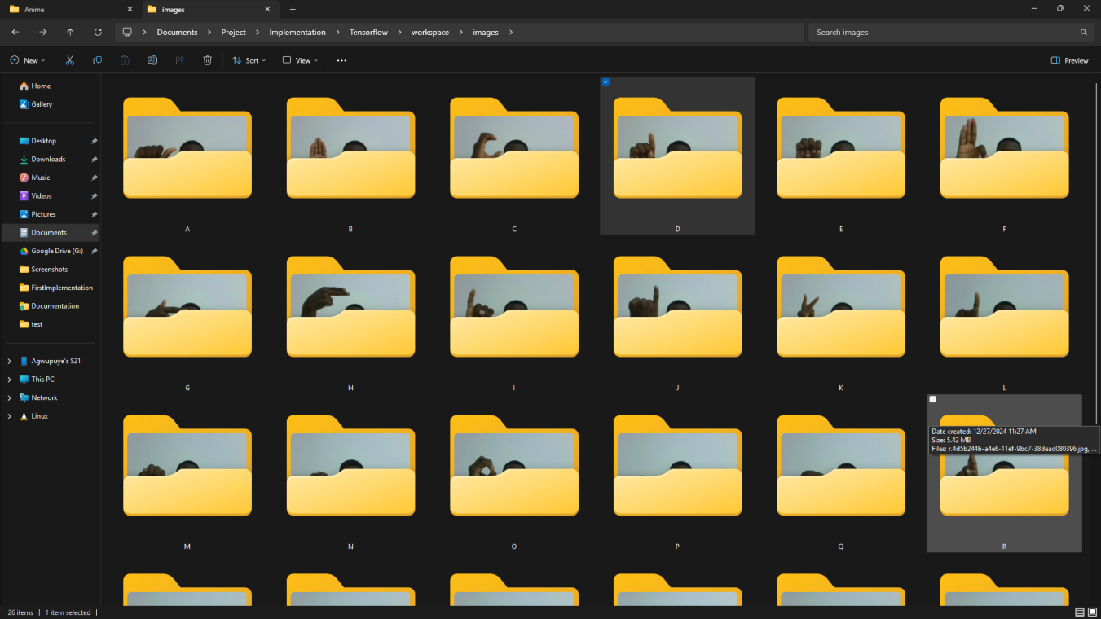

Fig 3.3 Folders containing images for various ASL alphabets

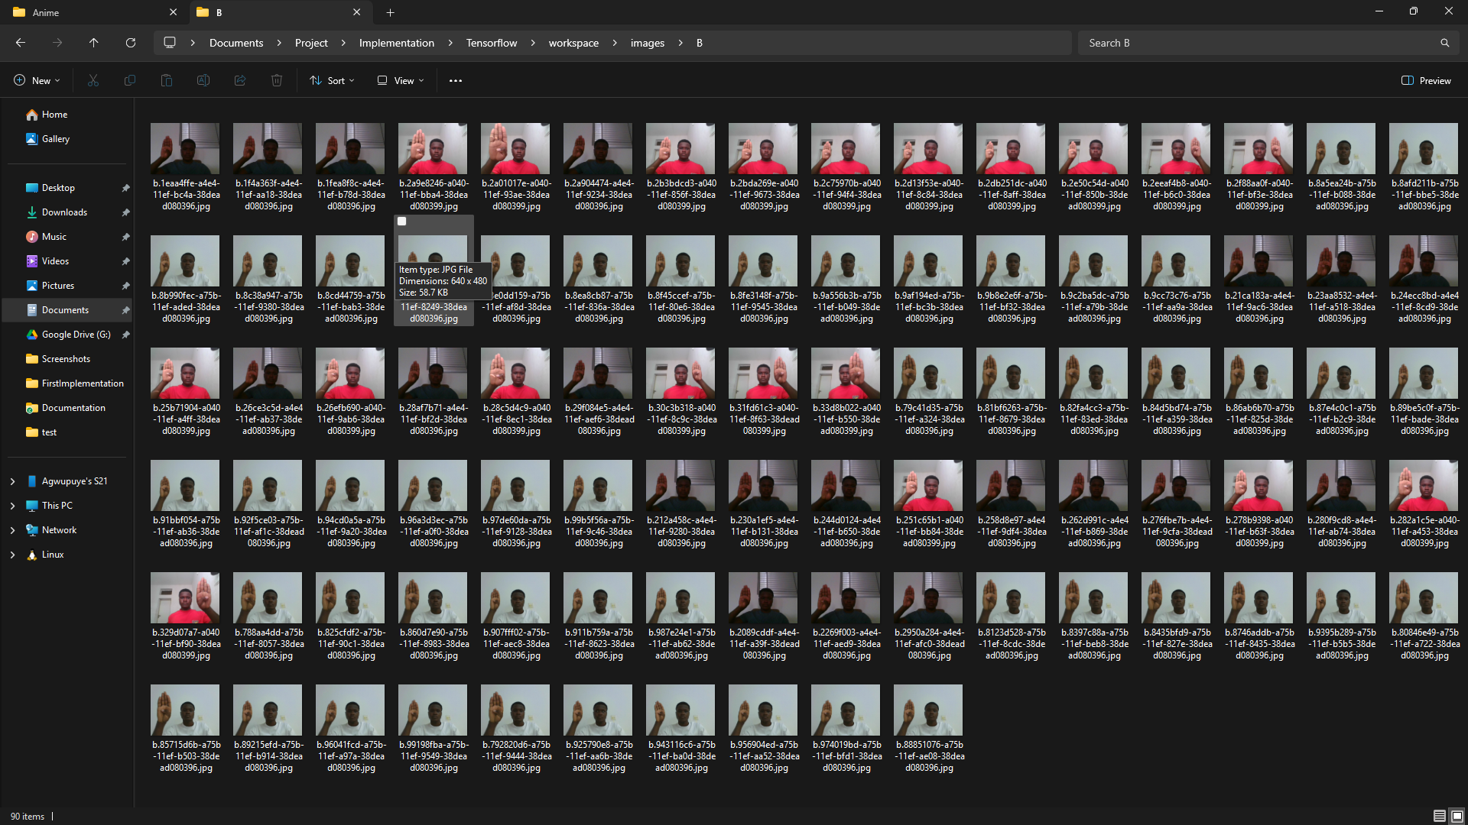

Fig 3.4 Images for class “b”

## 3.4 Tools and techniques

This project utilizes a combination of modern tools and technologies to create a robust and efficient sign language translation system. Each tool was chosen to meet specific needs of the project, from image processing and machine learning to front-end development and seamless integration. Below is an overview of the key tools and techniques employed:

**OpenCV:** OpenCV (Open Source Computer Vision Library) is a crucial component in this project for image and video processing. It is used to capture and process the video input of sign language gestures, enabling real-time detection and tracking of hand movements. OpenCV's powerful image analysis functions help pre-process the visual data, ensuring the input to the machine learning model is clean and accurate.

**TensorFlow:** TensorFlow is the primary machine learning framework used for building and training the sign language recognition model. It facilitates the development of a deep neural network capable of accurately interpreting hand gestures. TensorFlow's flexibility and comprehensive libraries allow for custom training and fine-tuning of the model, ensuring it performs well under various conditions, including different lighting scenarios.

**React.js:** React.js is employed to develop the front-end of the project. This JavaScript library is used to create a dynamic and responsive user interface that allows users to interact with the sign language translation system in real-time. React’s component-based structure makes it easy to manage the application’s state and seamlessly integrate the machine learning model once it’s converted to TensorFlow.js.

**Python:** Python is the primary programming language used for the back-end development and model training. It is leveraged for data processing, handling machine learning workflows, and managing the training environment. Python’s wide range of libraries and its compatibility with both OpenCV and TensorFlow make it an ideal choice for developing the machine learning aspects of the project.

## 3.5 Ethical consideration

Developing a sign language translation system involves several ethical considerations to ensure that the technology is inclusive, respectful, and used responsibly. These considerations have guided the design and implementation of the project to prioritize the well-being and dignity of users. Below are the primary ethical concerns addressed:

**Privacy and Data Security**: Given that this project involves capturing and processing video data of users’ hand movements, privacy is a top priority. All video input data is processed locally to prevent unauthorized access or storage of sensitive information. Additionally, strong encryption standards and best practices for data security are applied to safeguard any potentially sensitive user information.

**Inclusivity and Accessibility:** The core purpose of this project is to improve accessibility for the Deaf and Hard of Hearing communities. The design of the system aims to enhance communication without replacing or devaluing the cultural significance of sign languages. Therefore, the project acknowledges that technology should complement human communication and not replace it. This system is built to respect the richness and diversity of sign languages while providing a helpful translation aid.

**Transparency and Accountability**: Transparency in how the machine learning model operates is crucial to build trust with users. The project's design and development process includes clear documentation on the model's capabilities, limitations, and the data sources used for training. Regular audits and updates are planned to refine the model and address any emerging ethical concerns, making the project accountable to its intended users.

**Impact on the Community:** The potential impact of this technology on the Deaf and Hard of Hearing communities is carefully considered. This project aims to support communication rather than replacing human translators, recognizing that human interpretation is often irreplaceable due to the nuances and cultural context inherent in sign languages. The project remains open to feedback from these communities to ensure the system is developed in a way that truly benefits its users without unintentionally causing harm or misinterpretation.

## 3.6 Requirement analysis

The success of this sign language translation project relies heavily on a clear understanding of the system's functional and non-functional requirements. A detailed analysis was conducted to identify the key requirements needed to achieve the project’s objectives, ensuring that the final product is both effective and user-friendly. Below is an overview of the primary requirements:

#### 3.6.1 Functional requirements

Table 3.1 Functional Requirements

|  |  |
| --- | --- |
| Req. No | Description |
| R-101 | The system shall be able to perform Real-Time Gesture recognition |
| R-102 | The system shall Accurately detect hand signs |
| R-103 | The system shall be able to form simple words and sentences from ASL alphabets |
| R-104 | The user Interface shall be intuitive |
| R-105 | The system shall be compatible with different device types |
| R-106 | The system should allow users to register; giving only minimal information |
| R-107 | The system should allow users to login with registered information |
| R-108 | The system should be able to convert translated words and sentences into words |

#### 3.6.2 Non-Functional requirements

Table 3.2 Non-Functional Requirements specifications

|  |  |
| --- | --- |
| Req. No | Description |
| R-101 | The system shall maintain smooth and efficient performance, processing video input and generating translations with minimal latency. |
| R-102 | The architecture shall be scale-able to accommodate future expansions, including adding new gestures or adapting to different sign languages. |
| R-103 | The user interface shall be accessible, straightforward, and designed to accommodate users of all technical skill levels. |
| R-104 | The system shall achieve recognition accuracy above 90% for common sign language gestures under standard conditions. |
| R-105 | The code-base shall be well-documented and modular, allowing for easy maintenance, updates, and debugging. |

## 3.7 System design

**USER REGISTRATION:** This feature allows new users to create an account by providing minimal details such as email and password. The system verifies unique credentials before completing the registration process.

**LOGIN SYSTEM:** Users with an existing account can log in securely using their email and password. The backend handles authentication, ensuring only authorized users gain access.

**GESTURE DETECTION MODULE:** This is the core functionality of the system, where gestures captured through the user's video feed are processed to predict American Sign Language (ASL) letters. Predictions are sent back as single characters for further use in building sentences.

**FRONTEND:**

**Sentence Builder:** This component appends and stores letters received from the backend. It maintains and displays the current sentence being formed by the user.

**VIDEO INPUT MODULE:** The frontend captures video input from the user's webcam. It pre-processes frames before sending them to the backend for gesture prediction.

**BACKEND LOGIC:**

**Prediction Processor:** Collects gesture predictions within a 1.5-second window, and sends it back to the frontend.

**Space Logic:** Monitors for a second hand appearing in the frame and triggers the addition of a space character.

**TensorFlow Model Integration:** The trained ASL model processes gestures and generates predictions based on the user's hand Gestures.

**TEXT-TO-SPEECH (TTS):** Converts the constructed sentence into speech using the Speechify API. Users can input text and receive audio output, enhancing accessibility.

**USER INTERFACE:**

Camera Selection: Enables users to select from available cameras for gesture detection.

Controls: Provides buttons for starting/stopping gesture translation, clearing sentences, and navigating between features.

**DATABASE:** Stores user details (i.e., email, password) securely. MongoDB Atlas serves as the database backend.

**ERROR HANDLING MODULE:** Ensures graceful handling of issues such as model errors, API failures, or invalid user inputs, keeping the system robust and user-friendly.

#### 3.7.1 System architecture

The application diagram illustrates the structure of an application and demonstrates how various system components interact to fulfill users' needs.

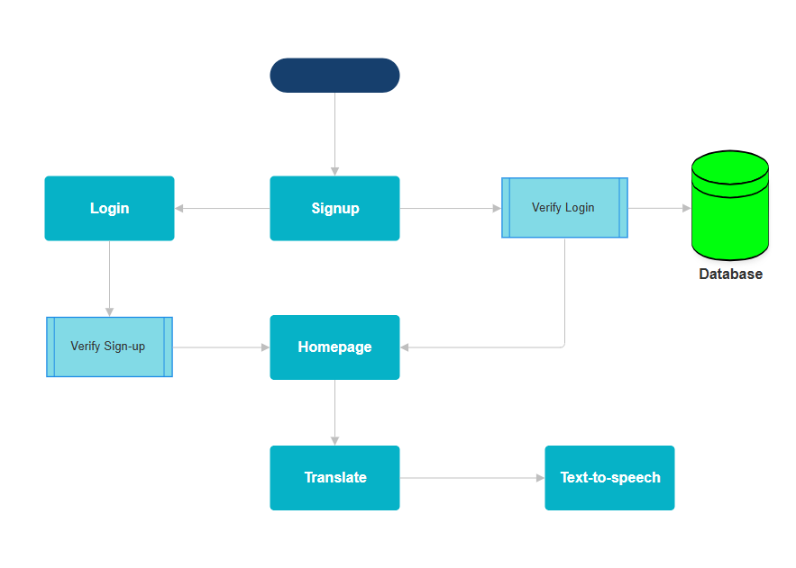

Fig 3.5 Application Architecture

#### 3.7.2 Use case diagram

In Fig 3.6 the actor named “user” can perform various actions in the program

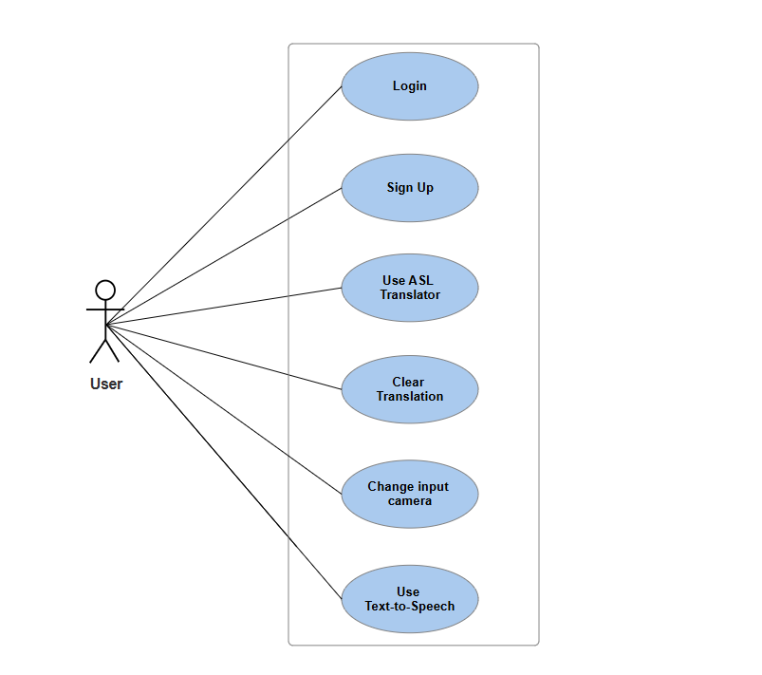

Fig 3.6 Use case diagram for User

#### 3.7.4 Activity Diagrams

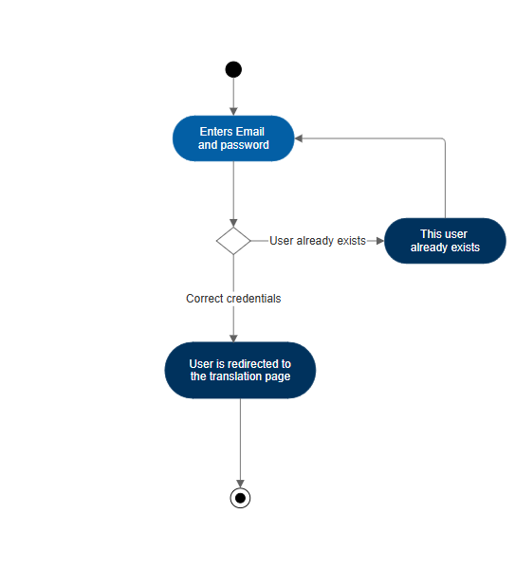

Fig 3.7 Activity diagram for user sign-up

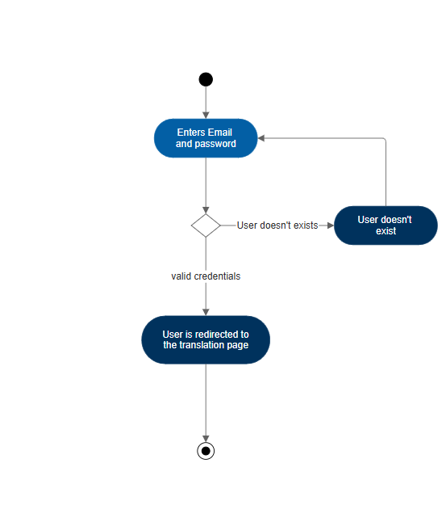

Fig 3.8 Activity diagram for user Login

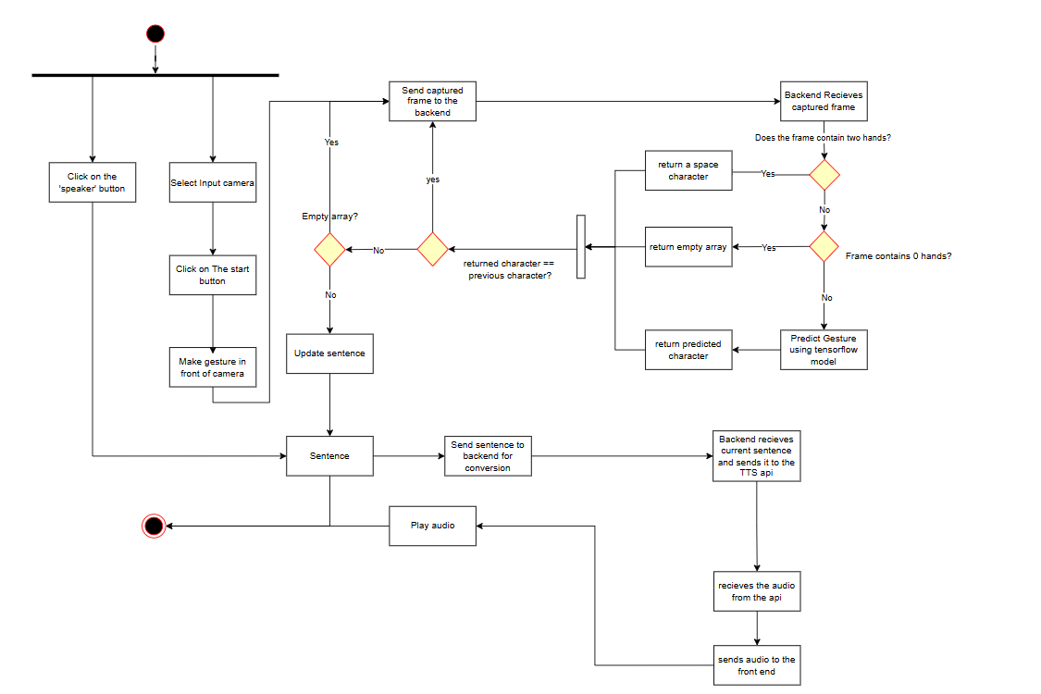

Fig 3.9 Activity diagram detailing the entire translation process

#### 3.7.5 Data Flow Diagrams

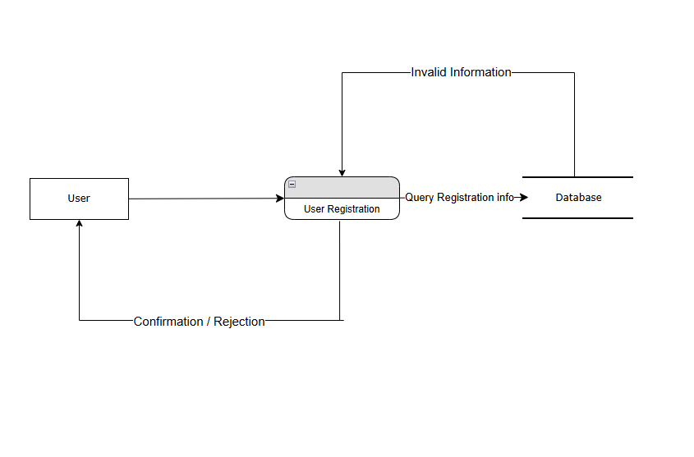

Fig 3.10 Data flow diagram for User sign-up

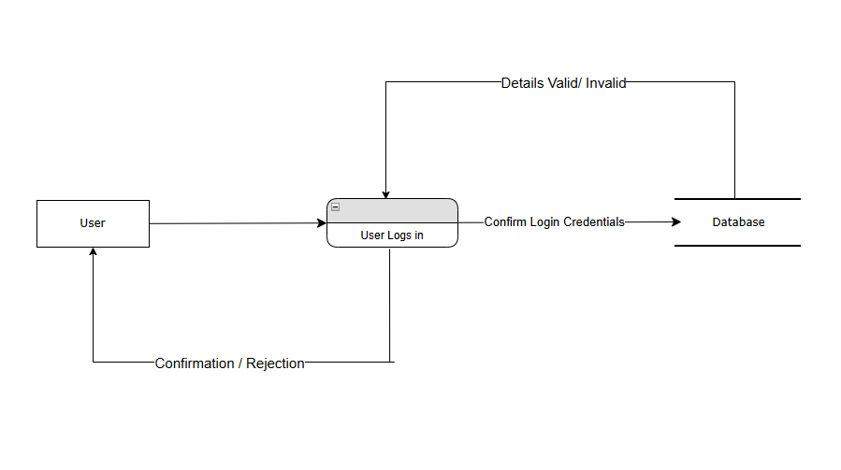

Fig 3.11 Data flow diagram for User Login

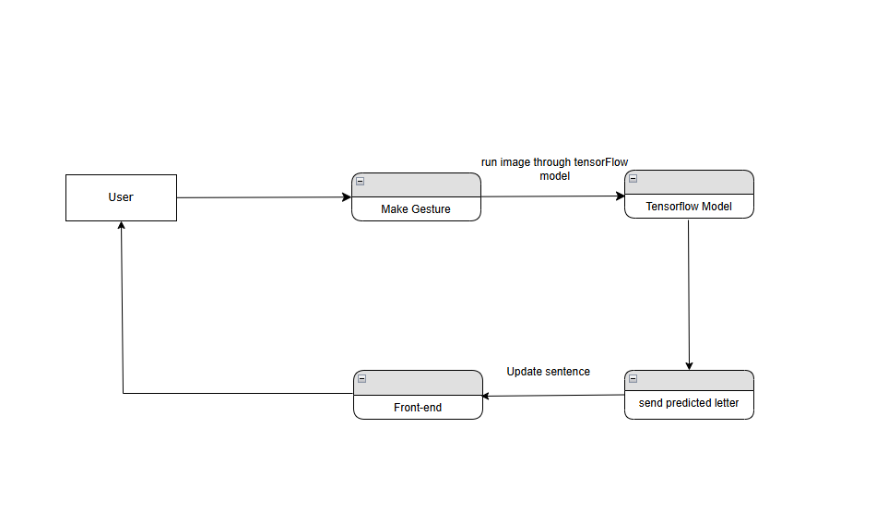

Fig 3.12 Data flow diagram for Translation

#### 3.7.6 User Interface

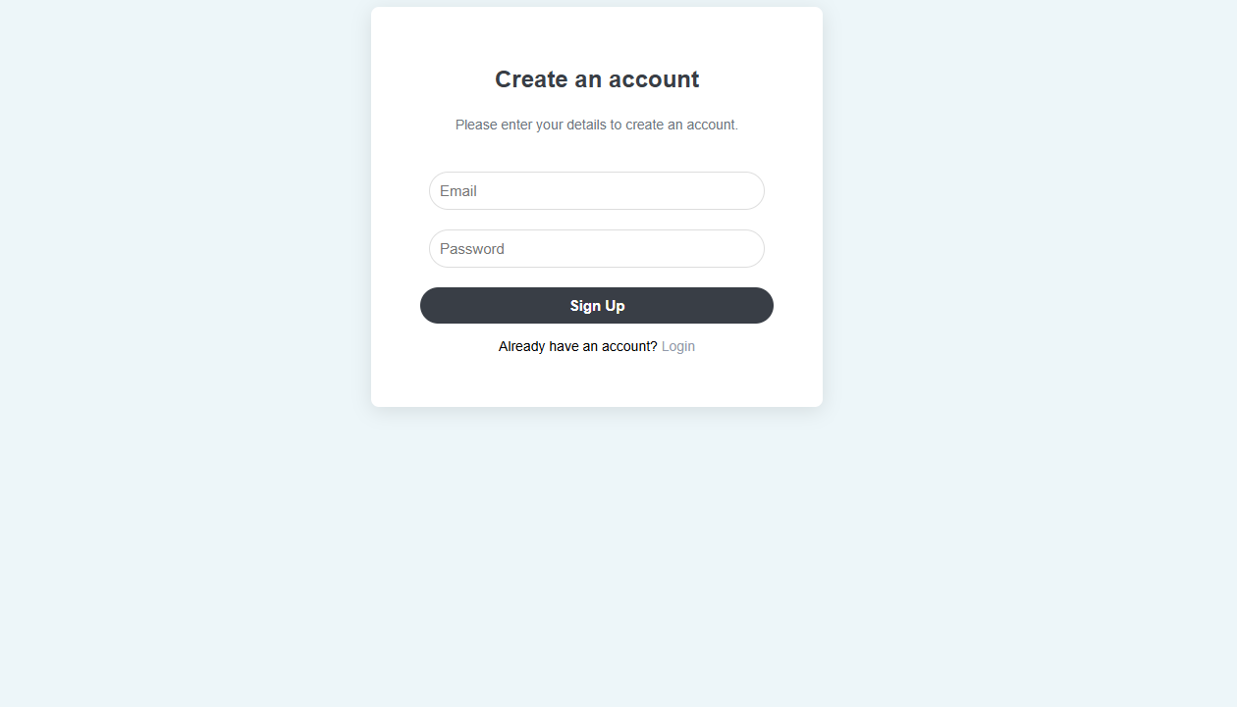

Fig 3.14 User interface for the sign-up page

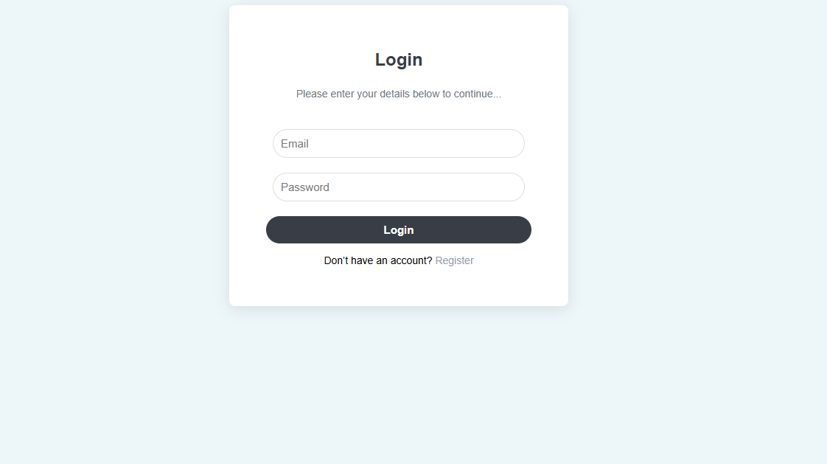

Fig 3.15 User interface for login page

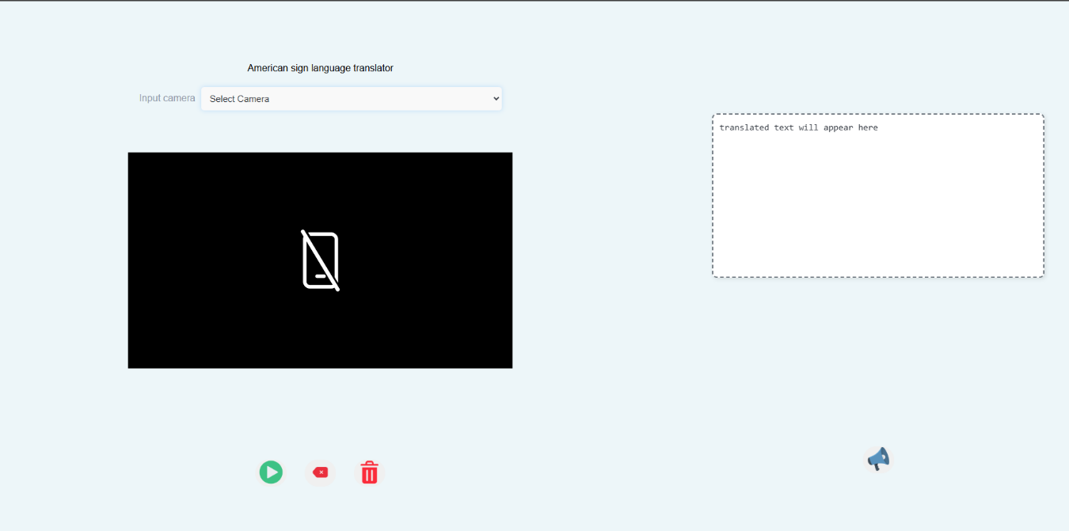

Fig 3.16 user interface for translation page

# CHAPTER 4

# TESTING AND IMPLEMENTATION

## 4.1 Overview

This chapter provides an overview of the development process for the gesture recognition-based system. It covers the integration of the trained gesture recognition model into a React application, including key components such as the front-end implementation, back-end support, and data handling. Additionally, it highlights the challenges faced during the development, such as real-world accuracy discrepancies for specific gesture classes, and details the strategies employed to address these issues effectively.

## 4.2 Main Features

The main features of the system are:

**Gesture Detection and Recognition:**  
The system integrates a gesture recognition model trained using TensorFlow and Mediapipe. It accurately detects hand gestures and maps them to specific letters of the alphabet. This feature allows users to interact with the system using physical gestures, forming the basis for creating words and sentences.

**Word and Sentence Formation:**  
Once gestures are recognized, the system processes them to form coherent words and sentences. Users can see the text generated in real-time, enabling seamless communication or transcription of gestures.

**Text-to-Speech Conversion:**  
After forming sentences, the system includes a text-to-speech (TTS) feature that converts the generated text into audio. This enables users to vocalize their messages, enhancing communication for individuals who may have difficulty speaking or prefer auditory output.

**Front-end Implementation:**  
A React-based front-end provides a user-friendly interface for interaction. It displays the detected gestures, the corresponding text output, and additional functionalities like clearing or resetting the output.

**Back-end Support:**  
The back-end processes the gesture recognition data and ensures smooth integration with the front-end. It also handles the text-to-speech requests and ensures efficient communication between the trained model and the interface.

**Error Handling and Accuracy Refinement:**  
The system includes logic to handle cases where gestures are inaccurately recognized or not detected at all. Strategies like predictive text suggestions or allowing users to re-perform gestures improve usability and performance.

**Real-Time Feedback:**  
The system provides immediate feedback to users as gestures are performed, ensuring an intuitive and responsive experience.

## 4.3 Implementation problems

During the development and implementation of the gesture recognition system, several challenges were encountered. These problems and the approaches taken to address them are detailed below:

**Accuracy Discrepancies in Gesture Recognition:**  
While the model performed well on training and testing datasets, real-world scenarios revealed inconsistencies in recognizing certain gestures. Variations in lighting, hand positioning, or user movement often affected accuracy.

**Integration with React Front-end:**  
Converting the trained TensorFlow model to TensorFlow Js posed some issues due to package dependency problems so integration with the React-based front-end posed challenges, especially with real-time gesture detection.

**Handling Ambiguous Gestures:**  
Some gestures, especially those resembling each other, were occasionally misclassified. This created confusion during word and sentence formation.

**Hardware Limitations:**  
Performance was affected on lower-end devices, especially when handling real-time gesture recognition and text-to-speech conversion.

## 4.4 Overcoming Implementation problems

The above mentioned were solved with the following methods.

* Additional data pre-processing was applied during training to simulate real-world conditions. Furthermore, fine-tuning the model and implementing logic to retry or confirm unclear gestures helped mitigate these issues.
* Developed a back-end server using Flask to host the TensorFlow model and seamlessly integrated it with the front-end. Optimization techniques were applied to minimize latency and ensure a smooth, responsive user experience.
* The system was equipped with error-handling mechanisms, such as requiring a gesture to be detected multiple times before being validated and added to the sentence.
* Code optimizations and the use of lightweight libraries ensured better performance across a wide range of devices.

## 4.5 Testing

To verify that the system functioned correctly and adhered to the specified requirements, tests were conducted from the perspective of end users to simulate real-world scenarios. This approach assessed the system's performance, its ability to handle errors effectively, and its overall usability. Various testing techniques, including unit testing, were employed to evaluate both the front-end and back-end components comprehensively.

#### 

#### 4.5.1 Test Plans (for Unit, Integration and System Testing)

**Table 4.1 Test Summary for user sign-up**

|  |  |
| --- | --- |
| Test case | User sign-up |
| Related Requirements | R-106 |
| Prerequisites | The registration page must be accessible, and the database must be connected. |
| Test Procedures | 1. Navigate to the "Sign Up" page.  2. Enter valid user details (e.g., username, email, password).  3. Click on the "Sign Up" button. |
| Test Data | Example: Username:"test_user",Email:"testuser@example.com", Password: "password123". |
| Expected Results | User details should be stored in the database, and be redirected to the homepage. |
| Actual Results | User details were stored in the database, and a confirmation message was displayed. |
| Status | Pass |
| Remarks | Email verification logic yet to be implemented. |
| Created By | Richard |
| Date of Creation | 26th December 2024 |
| Executed By | Richard |
| Date of Execution | 27th December 2024 |
| Test Environment | HP Laptop with Chrome browser. |

**Table 4.2 Test Summary for user Login**

|  |  |
| --- | --- |
| Test case | User Login |
| Related Requirements | R-107 |
| Prerequisites | The user account must exist in the database and be active. The login page must be accessible. |
| Test Procedures | 1. Navigate to the "Login" page.  2. Enter valid login credentials (e.g., email and password).  3. Click on the "Login" button.. |
| Test Data | Example:Username:"test_user",Email:"testuser@example.com", Password: "password123". |
| Expected Results | User should be redirected to their dashboard upon successful login. |
| Actual Results | User was redirected to the Homepage after successful login. |
| Status | Pass |
| Remarks | None |
| Created By | Richard |
| Date of Creation | 26th December 2024 |
| Executed By | Richard |
| Date of Execution | 27th December 2024 |
| Test Environment | HP Laptop with Chrome browser. |

**Table 4.3 Test Summary for Gesture Recognition Accuracy**

|  |  |
| --- | --- |
| Test case | Gesture Recognition Accuracy Testing |
| Related Requirements | R-102 |
| Prerequisites | Model must be trained and deployed. User must have access to a webcam-enabled device. |
| Test Procedures | 1. Perform gestures for each letter of the alphabet in front of the camera.  2. Check if the correct letter is displayed. |
| Test Data | Hand gestures for all 26 letters of the alphabet. |
| Expected Results | Recognized gesture should match the expected letter. |
| Actual Results | Correct letters were displayed for all gestures.. |
| Status | Pass |
| Remarks | Minor accuracy issues in low-light conditions were observed. |
| Created By | Richard |
| Date of Creation | 26th December 2024 |
| Executed By | Richard |
| Date of Execution | 27th December 2024 |
| Test Environment | HP Laptop with built-in webcam |

**Table 4.4 Test Summary for Sentence Formation**

|  |  |
| --- | --- |
| Test case | Sentence Formation Validation |
| Related Requirements | R-103 |
| Prerequisites | Gesture recognition feature must be functional. |
| Test Procedures | 1. Perform gestures for letters to form a word.  2. Continue gestures to create a full sentence.  3. Observe the output on the screen. |
| Test Data | Example input: gestures spelling "Hello World". |
| Expected Results | Recognized gestures should form coherent words and sentences. |
| Actual Results | Words and sentences formed accurately. |
| Status | Pass |
| Remarks | none. |
| Created By | Richard |
| Date of Creation | 26th December 2024 |
| Executed By | Richard |
| Date of Execution | 27th December 2024 |
| Test Environment | HP Laptop with built-in webcam |

**Table 4.5 Text-to-Speech Feature Testing**

|  |  |
| --- | --- |
| Test case | Text-to-Speech testing |
| Related Requirements | R-108 |
| Prerequisites | The sentence formation feature must be functional. |
| Test Procedures | 1. Form a sentence using gestures.  2. Click on the "Speak" button to activate the TTS feature. |
| Test Data | Input: "Hello, how are you?". |
| Expected Results | System should convert the text into clear, audible speech. |
| Actual Results | Text was successfully converted to speech. |
| Status | Pass |
| Remarks | Speech quality was clear with minimal delay.. |
| Created By | Richard |
| Date of Creation | 26th December 2024 |
| Executed By | Richard |
| Date of Execution | 27th December 2024 |
| Test Environment | HP Laptop with speakers. |

**Table 4.6 Real-Time Feedback Testing**

|  |  |
| --- | --- |
| Test case | Real-Time Gesture Feedback |
| Related Requirements | R-101 |
| Prerequisites | Gesture recognition feature must be functional. |
| Test Procedures | 1. Perform gestures for letters.  2. Observe if the recognized gesture appears immediately on the screen. |
| Test Data | Random gestures for letters A-Z. |
| Expected Results | Recognized gestures should display in real-time without noticeable lag.. |
| Actual Results | Real-time feedback was accurate and responsive. |
| Status | Pass |
| Remarks | None |
| Created By | Richard |
| Date of Creation | 26th December 2024 |
| Executed By | Richard |
| Date of Execution | 27th December 2024 |
| Test Environment | HP Laptop with built-in webcam. |

## 

## 4.6 User Guide

This section provides a step-by-step guide on how to use the system effectively, from registration to gesture translation and text-to-speech (TTS) functionalities.

**1. Registration**

To start using the system,

Navigate to the Registration Page.

Enter your email address and password.

Click on the Sign-Up button.

If registration is successful, you will be redirected to the translation page.

**2. Login**

To access your account:

Go to the Login Page.

Enter your registered email address and password.

Click the Login button.

If the credentials are correct, you will be redirected to the translation page.

**3. Using the Gesture Translation Module**

The gesture detection system uses your camera feed to identify hand gestures. When a hand gesture is detected, it is interpreted as a specific letter or space. The system allows for the construction of sentences in real time based on gestures made by the user.

**The application supports the following functionality:**

**Single letter gestures:** Each detected gesture corresponds to a specific letter, which is appended to the ongoing sentence.

**Space insertion:** When multiple hands are detected in the frame, a space is inserted between words.

**Consecutive letter detection:** If the same gesture is repeated consecutively, the system requires the user to remove their hand to reset the gesture before it can be appended again.

**Getting Started**

**Select a Camera:**

When the application starts, the available cameras are listed. Choose the camera you wish to use for gesture detection.

**Start Gesture Detection:**

Click on the Start button to begin gesture detection. The camera will start streaming, and the system will begin interpreting your gestures.

**Make Gestures:**

Perform hand gestures in front of the camera. Each gesture will be translated into a character or space, which will be appended to the sentence being constructed.

**Single gesture:** A single hand gesture is interpreted as a letter.

**Multiple hands:** If two hands are detected, a space is inserted between words.

**Gesture Handling**

The system handles gestures intelligently by considering the context of the detected gestures:

**Consecutive Gestures:** If the same gesture is detected consecutively, the system will wait for a hand removal to reset. This is to prevent accidental double-letter inputs. Once the hand is removed and the system is reset, the letter can be appended again.

**Message Notification:** If the system detects that the same gesture is repeated, it will display a message requesting the user to remove their hand to reset. The message will disappear after 2 seconds.

**Space Handling:** If multiple hands are detected, the system will automatically insert a space between the last letter and the next one. This allows for the construction of words separated by spaces.

**Resetting the System**

**Manual Reset:**

If you wish to reset the system manually, you can click the Clear button, which will remove the current sentence being constructed.

**Automatic Reset:**

The system automatically resets when a hand is removed from the frame, clearing the state and preventing consecutive letter appends. This ensures that the system is always ready for a new gesture.

**Troubleshooting**

**No Gestures Detected:**

Ensure that your hands are within the camera’s frame and well-lit. If no gestures are detected, try adjusting your position or lighting.

**Space Not Inserting:**

If a space is not inserted when multiple hands are detected, check that both hands are clearly visible in the frame.

**Tips for Better Accuracy**

Lighting: Proper lighting improves the system’s ability to accurately detect your hand gestures. Ensure the camera has a clear view of your hands with enough contrast.

**Gesture Consistency:** Perform gestures clearly and consistently to avoid misinterpretation.

**Hand Position:** Position your hands in the center of the frame for better detection. Ensure that the gesture is fully formed and recognizable by the system.

**5. Text-to-Speech (TTS)**

Click on the speaker button.

The system processes the translated text and generates an audio output.

Play the audio directly from the browser.

**7. Error Messages**

Invalid Login: Check your email and password for errors.

## 4.7 Summary

The testing of a system is a critical step in ensuring the final version is functional, reliable, and meets the needs of its intended users. For this project, various stages of testing were conducted to evaluate the usability and performance of the system. Through rigorous testing, any identified issues were promptly addressed and resolved to improve the system's quality. The testing process ensured that the system is ready for deployment and user interaction.

# CHAPTER 5

# Discussion, Conclusion and Recommendation

## 5.1 Overview

This chapter provides an evaluation of the project, including the challenges encountered during its development and possible future enhancements. It assesses the extent to which the project objectives were achieved and identifies areas for improvement to optimize functionality and user experience.

## 5.2 Objective Assessment

The primary objectives of this project were successfully achieved. These include:

Enabling the translation of American Sign Language (ASL) gestures into text using a digital platform.

Allowing users to interact with a real-time gesture recognition system and view translated text.

The system allows users to communicate effectively by recognizing gestures and converting them into written text or audio output. While advancements in AI and computer vision technologies continue, the system can be updated to remain relevant and accurate.

## 5.3 Limitations and Challenges

The project encountered several limitations and challenges during its development, including:

**Time Management:**

Balancing the workload of academic responsibilities and system development required strategic time allocation.

**Learning Curve:**

Familiarity with new technologies such as TensorFlow, Mediapipe, and Flask presented initial difficulties but was overcome through research and practice.

**Hardware Constraints:**

Testing and debugging on devices with limited processing power sometimes resulted in slower performance.

**Users must meet certain requirements to interact with the system effectively:**

A device equipped with a functional camera and internet connection.

Adequate lighting for accurate hand gesture recognition.

Updated browsers and operating systems to support the application.

## 5.4 Future Enhancements

Although the project met its core objectives, there are features that could be incorporated in future iterations to improve the system:

**Improved Accuracy:**

Enhance the machine learning model with a more extensive and diverse dataset for better gesture recognition accuracy.

**Additional Gestures:**

Extend support to more gestures, including phrases and cultural variations in ASL.

**User Personalization:**

Include customizable voice options for text-to-speech output to suit individual preferences.

## 5.5 Recommendations

To enhance the usability and adoption of the system, the following measures are recommended:

**User Training:**

Provide tutorials or guides for users to understand the gesture recognition process and optimize their interaction with the system.

**Regular Updates:**

Periodically update the system to include new features and improve existing ones.

**User Feedback Integration:**

Establish a feedback mechanism to gather insights from users and address their needs effectively.

## 5.6 Summary

This chapter concludes the project documentation. It includes an overview of the project’s goals, the challenges encountered, and their solutions, as well as recommendations for future improvements. The project achieved its primary objectives of providing a gesture-to-text and text-to-speech system, ensuring inclusivity for users. Through systematic testing and continuous iteration, the system was made reliable and efficient. Future advancements can further enhance its scope and usability, ensuring it remains a valuable tool for communication.

# REFERENCES

Adib Burhani, Z. M., & Prasetyo, J. (2023). The Sign Language Interpreting Gloves. J. Of App. Sci. & Adv. Eng. <https://doi:10.59097/jasae.v1i1.10>

Ahmed, M. A., Zaidan, B. B., Zaidan, A. A., Salih, M. M., & Lakulu, M. M. (2018). A Review on Systems-Based Sensory Gloves for Sign Language Recognition State of the Art Between 2007 and 2017. Sensors. <https://doi:10.3390/s18072208>

Alobaidy, M. A., & Ebraheem, S. (2020). Application for Iraqi Sign Language Translation on Android System. International Journal of Electrical and Computer Engineering (Ijece). <https://doi:10.11591/ijece.v10i5.pp5227-5234>

Arssi, A. and Taibi, N. (2018). Sign language interpreter: what makes it different? Sino-Us English Teaching, 15(8). <https://doi.org/10.17265/1539-8072/2018.08.004>

Axyonov, A., Ryumin, D., & Kagirov, I. (2021). Method of Multi-Modal Video Analysis of Hand Movements for Automatic Recognition of Isolated Signs of Russian Sign Language. The International Archives of the Photogrammetry Remote Sensing and Spatial Information Sciences. <https://doi:10.5194/isprs-archives-xliv-2-w1-2021-7-2021>

Baltrušaitis, T., Ahuja, C., & Morency, L. (2019). Multimodal Machine Learning: A Survey and Taxonomy. Ieee Transactions on Pattern Analysis and Machine Intelligence. <https://doi:10.1109/tpami.2018.2798607>

Bantupalli, K., & Xie, Y. (2018). American Sign Language Recognition Using Deep Learning and Computer Vision. <https://doi:10.1109/bigdata.2018.8622141>

Bochner, J. H., Christie, K., Hauser, P. C., & Searls, J. M. (2011). When Is a Difference Really Different? Learners’ Discrimination of Linguistic Contrasts in American Sign Language. Language Learning. <https://doi:10.1111/j.1467-9922.2011.00671.x>

Camgöz, N. C., Hadfield, S., Koller, O., Ney, H., & Bowden, R. (2018). Neural Sign Language Translation. <https://doi:10.1109/cvpr.2018.00812>

Chen, X., Su, L., Zhao, J., Qiu, K., Jiang, N., & Zhai, G. (2023). Sign Language Gesture Recognition and Classification Based on Event Camera With Spiking Neural Networks. Electronics. <https://doi:10.3390/electronics12040786>

Chong, V. Y. (2024). The Design of the Deaf in Touch Everywhere (DITE)TM Mobile Application With Deaf and Interpreter Communities in Malaysia. Digital Health. <https://doi:10.1177/20552076241228432>

Dean, R. K., & Pollard, R. Q. (2001). Application of Demand-Control Theory to Sign Language Interpreting: Implications for Stress and Interpreter Training. The Journal of Deaf Studies and Deaf Education. <https://doi:10.1093/deafed/6.1.1>

Delisle, A., Larivière, C., Imbeau, D., & Durand, M.-J. (2005). Physical Exposure of Sign Language Interpreters: Baseline Measures and Reliability Analysis. European Journal of Applied Physiology. <https://doi:10.1007/s00421-005-1316-5>

Donner, A., Marshall, M. S., & Mozrall, J. (2013). Biomechanical Comparison of American Sign Language Interpretation and Conversation. Proceedings of the Human Factors and Ergonomics Society Annual Meeting. <https://doi:10.1177/1541931213571083>

Elmahgiubi, M., Ennajar, M., Drawil, N., & Elbuni, M. S. (2015). Sign Language Translator and Gesture Recognition. <https://doi:10.1109/gscit.2015.7353332>

Eng Tju, T. E. (2024). Hand Sign Interpretation Through Virtual Reality Data Processing. Jurnal Ilmu Komputer Dan Informasi. <https://doi:10.21609/jiki.v17i2.1280>

Falchook, A. D., Mayberry, R. I., Poizner, H., Burtis, D. B., Doty, L., & Heilman, K. M. (2013). Sign Language Aphasia From a Neurodegenerative Disease. Neurocase. <https://doi:10.1080/13554794.2012.690427>

Fathima, T. (2024). Real-Time Sign Language Recognition and Translation Using Deep Learning Techniques. Int Res J Adv Engg Hub. <https://doi:10.47392/irjaeh.2024.0018>

Fernando, P. and Wimalaratne, P. (2016). Sign language translation approach to sinhalese language. GSTF Journal on Computing (Joc), 5(1). <https://doi.org/10.7603/s40601-016-0009-8>

Ghoul, O. E. (2023). JUMLA-QSL-22: A Novel Qatari Sign Language Continuous Dataset. Ieee Access. <https://doi:10.1109/access.2023.3324040>

Huamani-Malca, J. (2018). Less Is More: Techniques to Reduce Overfitting in Your Transformer Model for Sign Language Recognition. <https://doi:10.52591/lxai2023061812>

Hughes, G., Hudgins, B., & MacDougall, J. (2004). Remote Sign Language Interpretation Using the Internet. <https://doi:10.1109/dnsr.2004.1344750>

Iduar Perdana, I. P. (2021). Classification of Sign Language Numbers Using the CNN Method. Jitter Jurnal Ilmiah Teknologi Dan Komputer. <https://doi:10.24843/jtrti.2021.v02.i03.p07>

Khuzayem, L. A. (2024). Efhamni: A Deep Learning-Based Saudi Sign Language Recognition Application. Sensors. <https://doi:10.3390/s24103112>

Koller, O., Zargaran, S., Ney, H., & Bowden, R. (2018). Deep Sign: Enabling Robust Statistical Continuous Sign Language Recognition via Hybrid CNN-HMMs. International Journal of Computer Vision. <https://doi:10.1007/s11263-018-1121-3>

Kumar, Y. (2024). Applying Swin Architecture to Diverse Sign Language Datasets. Electronics. <https://doi:10.3390/electronics13081509>

Lee, P. H., Spooner, C., & Harris, M. E. (2021). Access and Communication for Deaf Individuals in Australian Primary Care. Health Expectations. <https://doi:10.1111/hex.13336>

Liao, Y., Xiong, P., Min, W., Min, W., & Lu, J. (2019). Dynamic Sign Language Recognition Based on Video Sequence With BLSTM-3D Residual Networks. Ieee Access. <https://doi:10.1109/access.2019.2904749>

Lin, H. and Murli, N. (2022). Bim sign language translator using machine learning (tensorflow). Journal of Soft Computing and Data Mining, 3(1). <https://doi.org/10.30880/jscdm.2022.03.01.007>

Luqman, H., & El-Alfy, E.-S. M. (2021). Towards Hybrid Multimodal Manual and Non-Manual Arabic Sign Language Recognition: mArSL Database and Pilot Study. Electronics. <https://doi:10.3390/electronics10141739>

Madahana, M. C. I., Khoza-Shangase, K., Moroe, N., Mayombo, D., Nyandoro, O. T., & Ekoru, J. E. D. (2022). A Proposed Artificial Intelligence-Based Real-Time Speech-to-Text to Sign Language Translator for South African Official Languages for the COVID-19 Era and Beyond: In Pursuit of Solutions for the Hearing Impaired. South African Journal of Communication Disorders. <https://doi:10.4102/sajcd.v69i2.915>

Marin, G., Dominio, F., & Zanuttigh, P. (2014). Hand Gesture Recognition With Leap Motion and Kinect Devices. <https://doi:10.1109/icip.2014.7025313>

Marschark, M., Pelz, J. B., Convertino, C., Sapere, P., Arndt, M. E., & Seewagen, R. (2005). Classroom Interpreting and Visual Information Processing in Mainstream Education for Deaf Students: Live or Memorex<sup>®? American Educational Research Journal. <https://doi:10.3102/00028312042004727>

McFarland, D. J., & Wolpaw, J. R. (2018). Brain–computer Interface Use Is a Skill That User and System Acquire Together. Plos Biology. <https://doi:10.1371/journal.pbio.2006719>

McKee, R. (2014). Breaking News: Sign Language Interpreters on Television During Natural Disasters. Interpreting International Journal of Research and Practice in Interpreting. <https://doi:10.1075/intp.16.1.06kee>

Meador, H. E., & Zazove, P. (2005). Health Care Interactions With Deaf Culture. The Journal of the American Board of Family Medicine. <https://doi:10.3122/jabfm.18.3.218>

Mehta, N. A., Starner, T., Jackson, M. M., Babalola, K. O., & James, G. A. (2010). Recognizing Sign Language From Brain Imaging. <https://doi:10.1109/icpr.2010.936>

Napier, J. (2004). Sign Language Interpreter Training, Testing, and Accreditation: An International Comparison. American Annals of the Deaf. <https://doi:10.1353/aad.2005.0007>

Network. European Journal of Electrical Engineering and Computer Science. <https://doi:10.24018/ejece.2021.5.3.332>

Oh, J., Jeon, S., Kim, B., Kim, M., Kang, S.-W., Kwon, H.-C., … Song, Y. (2017). Avatar-Based Sign Language Interpretations for Weather Forecast and Other TV Programs. Smpte Motion Imaging Journal. <https://doi:10.5594/jmi.2016.2632278>

Olabanji, A. O., & Ponnle, A. A. (2021). Development of a Computer Aided Real-Time Interpretation System for Indigenous Sign Language in Nigeria Using Convolutional Neural

Papastratis, I., Chatzikonstantinou, C., Konstantinidis, D., Dimitropoulos, K., & Daras, P. (2021). Artificial Intelligence Technologies for Sign Language. Sensors. <https://doi:10.3390/s21175843>

Pendergrass, K. M., Newman, S. D., Jones, E. G., & Jenkins, C. (2017). Deaf: A Concept Analysis From a Cultural Perspective Using the Wilson Method of Concept Analysis Development. Clinical Nursing Research. <https://doi:10.1177/1054773817719821>

Quinto‐Pozos, D. (2011). Teaching American Sign Language to Hearing Adult Learners. Annual Review of Applied Linguistics. <https://doi:10.1017/s0267190511000195>

Rodríguez-Tapia, B., Ochoa-Zezzatti, A., Soto Marrufo, Á. I., Arballo, N. C., & Carlos, P. A. (2019). Sign Language Recognition Based on EMG Signals Through a Hibrid Intelligent System. Research in Computing Science. <https://doi:10.13053/rcs-148-6-19>

Saladin, S. P., & Hansmann, S. (2008). Psychosocial Variables Related to the Adoption of Video Relay Services Among Deaf or Hard-of-Hearing Employees at the Texas School for the Deaf. Assistive Technology. <https://doi:10.1080/10400435.2008.10131930>

Salagar, M., Kulkarni, P., & Gondane, S. (2013). Implementation of Dynamic Time Warping for Gesture Recognition in Sign Language Using High Performance Computing. <https://doi:10.1109/ichci-ieee.2013.6887814>

Santos, A. S., & Freire Portes, A. J. (2019). Perceptions of Deaf Subjects About Communication in Primary Health Care. Revista Latino-Americana De Enfermagem. https://doi:10.1590/1518- 8345.2612.3127

Sevli, O., & Kemaloğlu, N. (2020). Turkish Sign Language Digits Classification With CNN Using Different Optimizers. International Advanced Researches and Engineering Journal. <https://doi:10.35860/iarej.700564>

Stefanidis, K., Konstantinidis, D., Kalvourtzis, A., Dimitropoulos, K., & Daras, P. (2020). 3D Technologies and Applications in Sign Language. <https://doi:10.4018/978-1-5225-5294-9.ch003>

Sun, C., Zhang, T., & Xu, C. (2015). Latent Support Vector Machine Modeling for Sign Language Recognition With Kinect. Acm Transactions on Intelligent Systems and Technology. <https://doi:10.1145/2629481>

Tannenbaum-Baruchi, C., & Feder-Bubis, P. (2017). New Sign Language New(S): The Globalization of Sign Language in the Smartphone Era. Disability & Society. <https://doi:10.1080/09687599.2017.1383034>

van Dijk, R., Christoffels, I. K., Postma, A., & Hermans, D. (2011). The Relation Between the Working Memory Skills of Sign Language Interpreters and the Quality of Their Interpretations. Bilingualism Language and Cognition. <https://doi:10.1017/s1366728911000198>

Verma, P., & Badli, K. (2022). Real-Time Sign Language Detection Using TensorFlow, OpenCV and Python. International Journal for Research in Applied Science and Engineering Technology. <https://doi:10.22214/ijraset.2022.43439>

Wadhawan, A., & Kumar, P. (2019). Sign Language Recognition Systems: A Decade Systematic Literature Review. Archives of Computational Methods in Engineering. <https://doi:10.1007/s11831-019-09384-2>

Wang, P., Zhou, Y., Li, Z., Huang, S., & Zhang, D. (2021). Neural Decoding of Chinese Sign Language With Machine Learning for Brain–Computer Interfaces. Ieee Transactions on Neural Systems and Rehabilitation Engineering. <https://doi:10.1109/tnsre.2021.3137340>

Yang, T. (2019). Comparison of Chinese and American Sign Language Interpretation Majors and Some Enlightenment. <https://doi:10.2991/assehr.k.191221.014>

ZainEldin, H. (2024). Silent No More: A Comprehensive Review of Artificial Intelligence, Deep Learning, and Machine Learning in Facilitating Deaf and Mute Communication. Artificial Intelligence Review. <https://doi:10.1007/s10462-024-10816-0>

Zhang, W. (2022). Sign Language Recognition Based on Depth Image Processing. Highlights in Science Engineering and Technology. <https://doi:10.54097/hset.v23i.3123>

# Appendix A - Project Document

**IN-DEPTH PROJECT DOCUMENTATION**

**Full Candidate Name:** Agwupuye Richard Ukwu

**Student ID:** BU/22A/IT/6308

**Title:** Sign Language Translation Using Gesture recognition with TensorFlow

**Course of Study:** B.Sc. Computer Science.

**Background and Motivation**

Effective communication is fundamental to human interaction. However, individuals who rely on American Sign Language (ASL) often face barriers when communicating with those unfamiliar with the language. These barriers highlight the need for technological solutions to bridge this communication gap.

With advancements in machine learning and computer vision, it is now possible to create systems that can recognize hand gestures in real-time and translate them into text or speech. Such a system not only empowers the ASL community but also fosters inclusivity in workplaces, educational institutions, and social settings.

The motivation for this project stems from the desire to address these communication barriers and leverage technology to create a more inclusive society. By providing a platform that accurately translates ASL gestures, individuals with hearing or speech impairments can participate more fully in everyday activities and have their voices heard.

**Statement of the Problem**

The lack of accessible tools for real-time ASL translation continues to hinder effective communication between ASL users and non-signers. Current solutions often require expensive equipment or fail to meet accuracy and usability expectations.

**Key problems include:**

**Manual Dependency:** Existing methods rely heavily on human interpretation, which may not always be feasible or accurate.

**Limited Accessibility:** Many available systems are costly or require specialized hardware, limiting their reach.

This project addresses these challenges by providing an affordable, accessible, and efficient ASL translation system using widely available hardware such as cameras and modern browsers. The solution focuses on accuracy, ease of use, and fostering inclusivity in communication.

# Appendix B- Source Codes

Sign-Up page

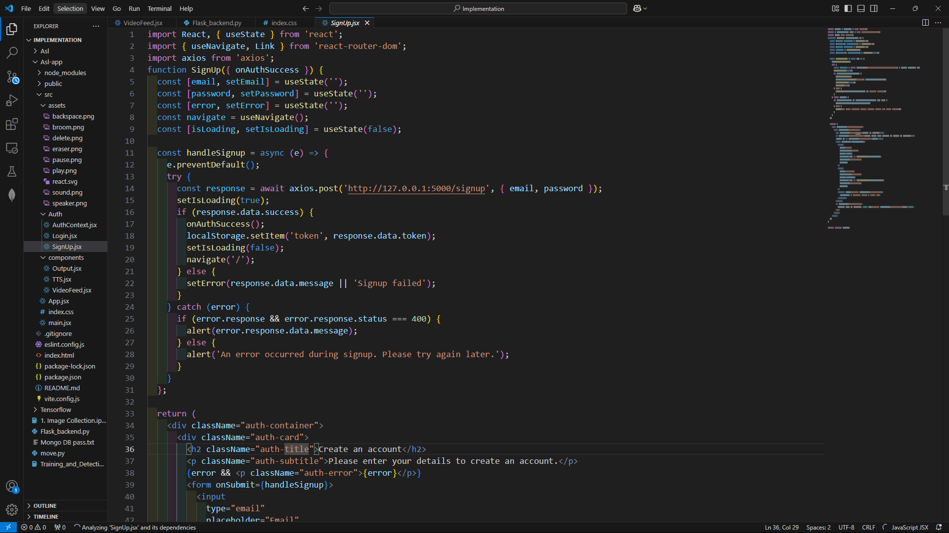

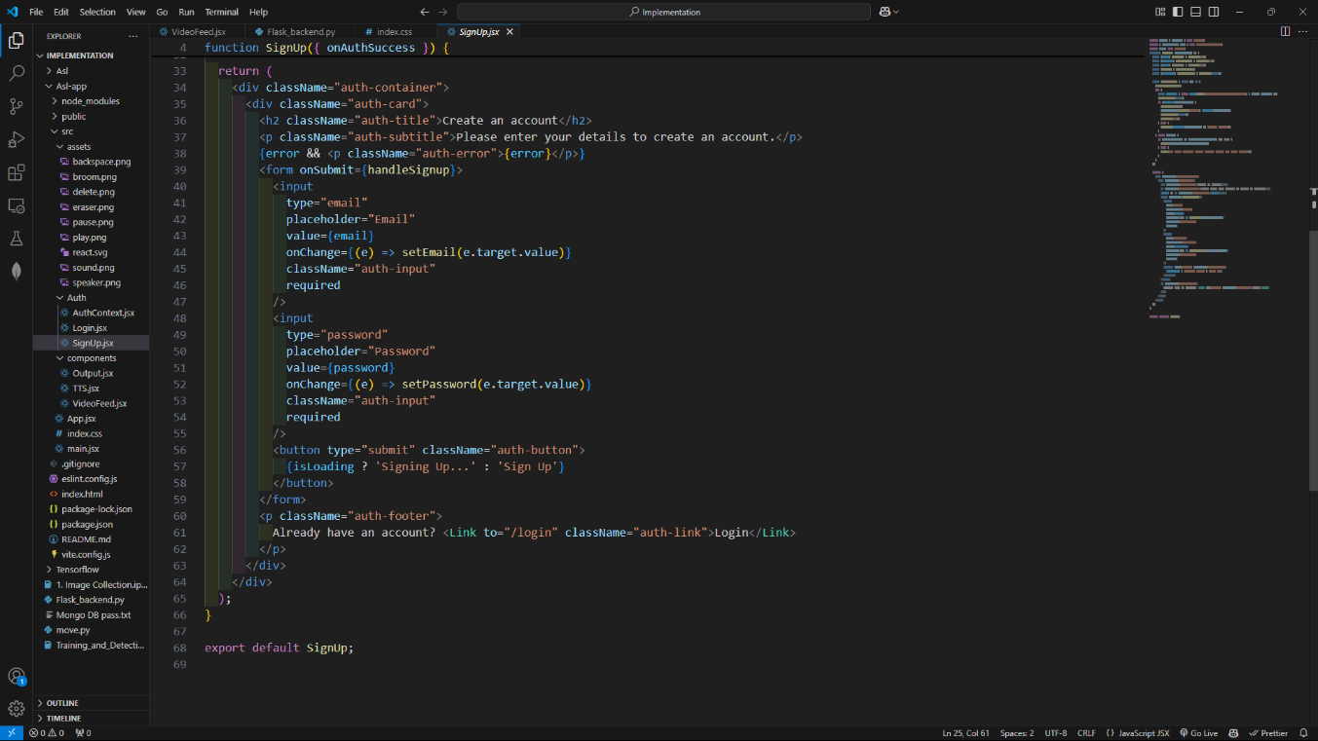

Login page:

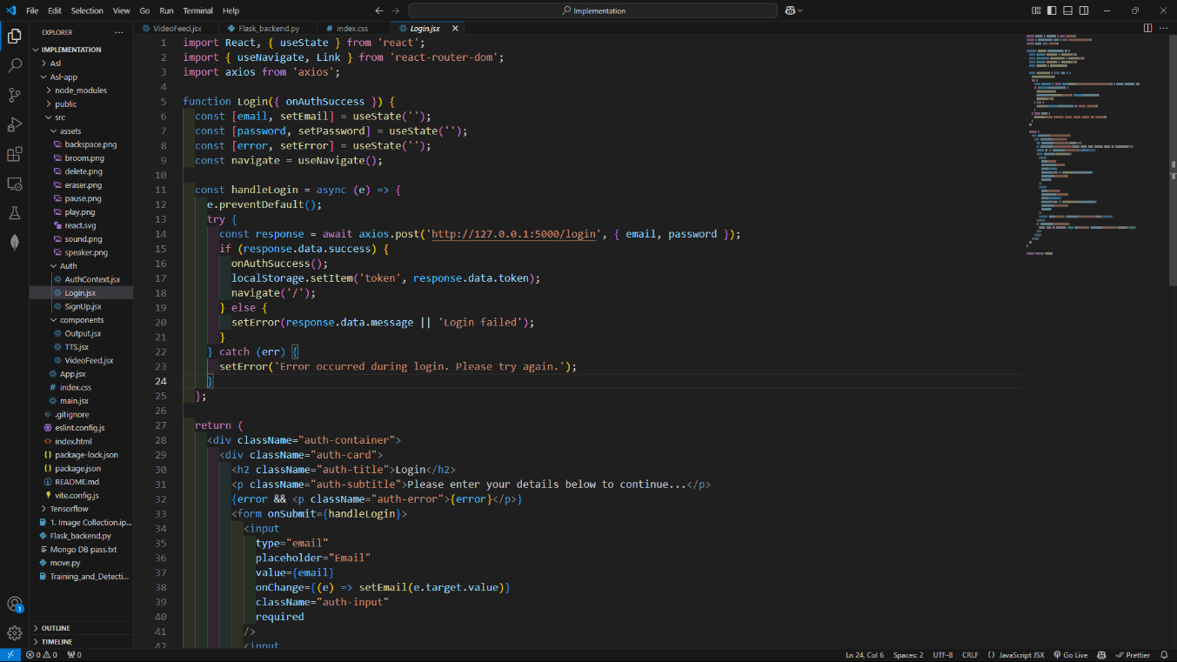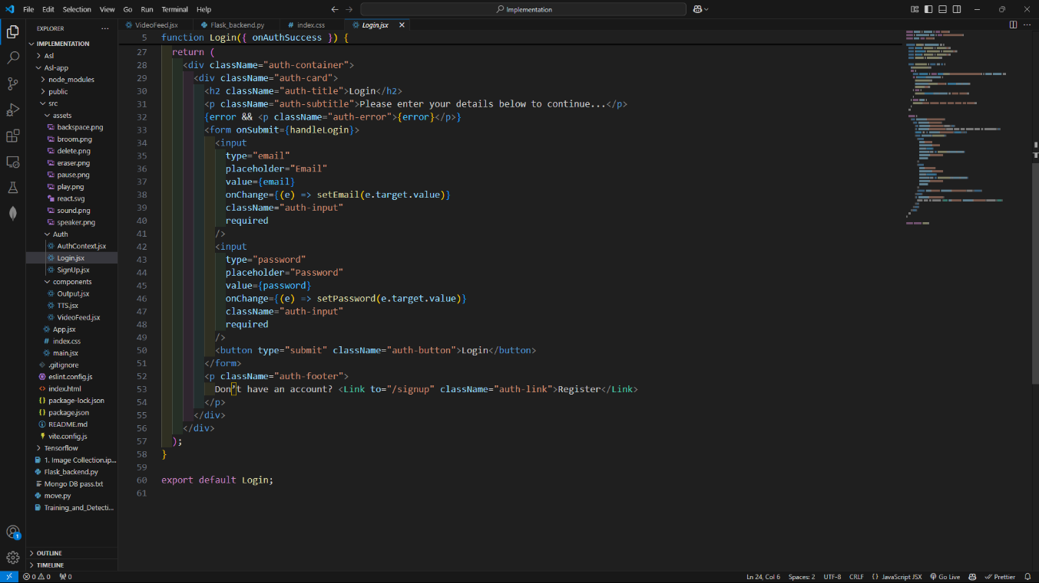

Translation page:

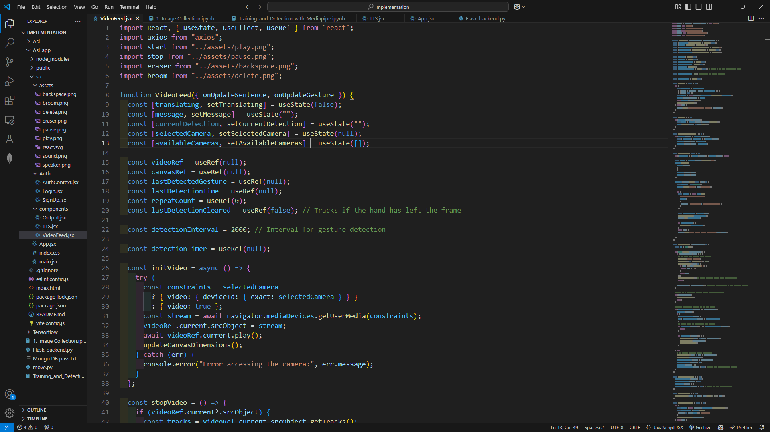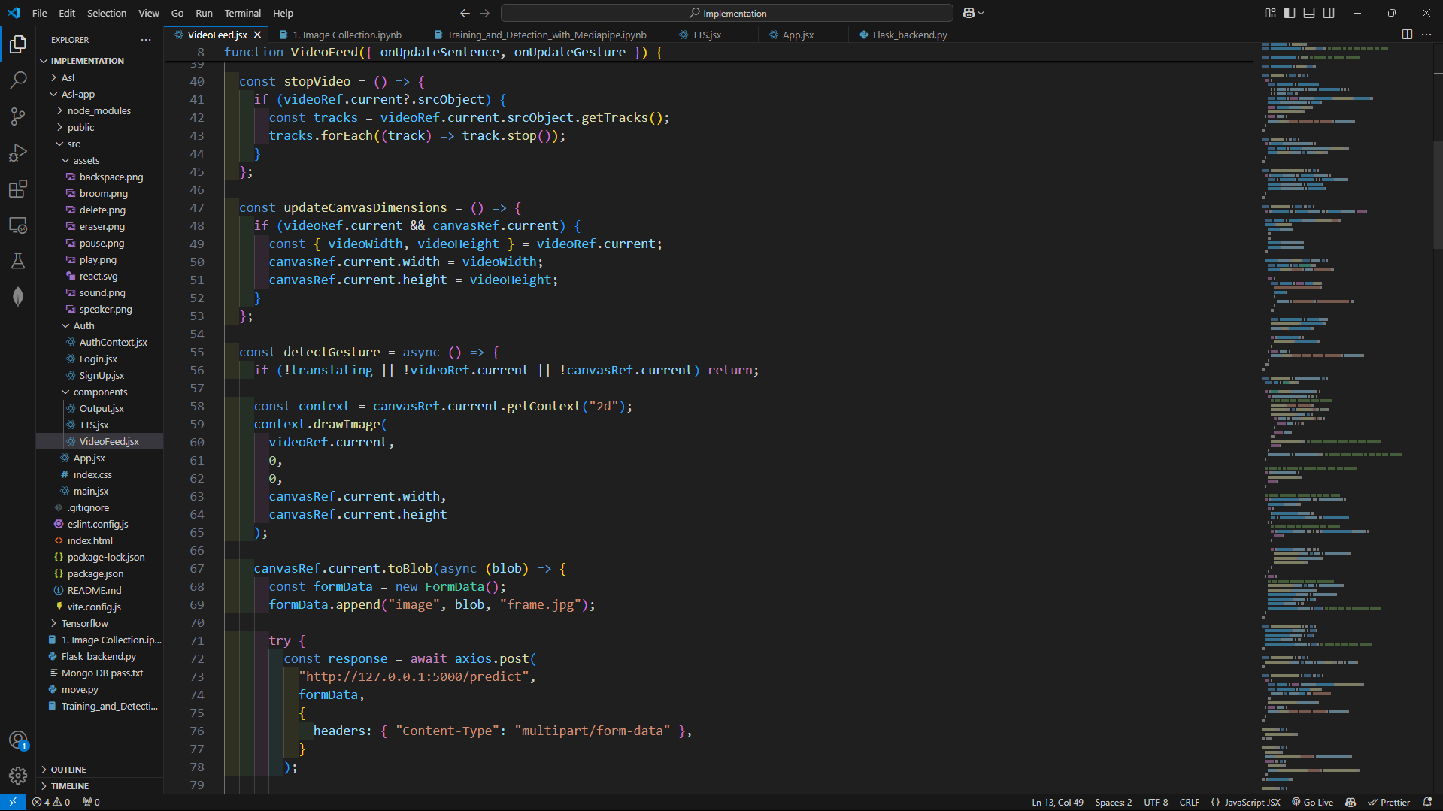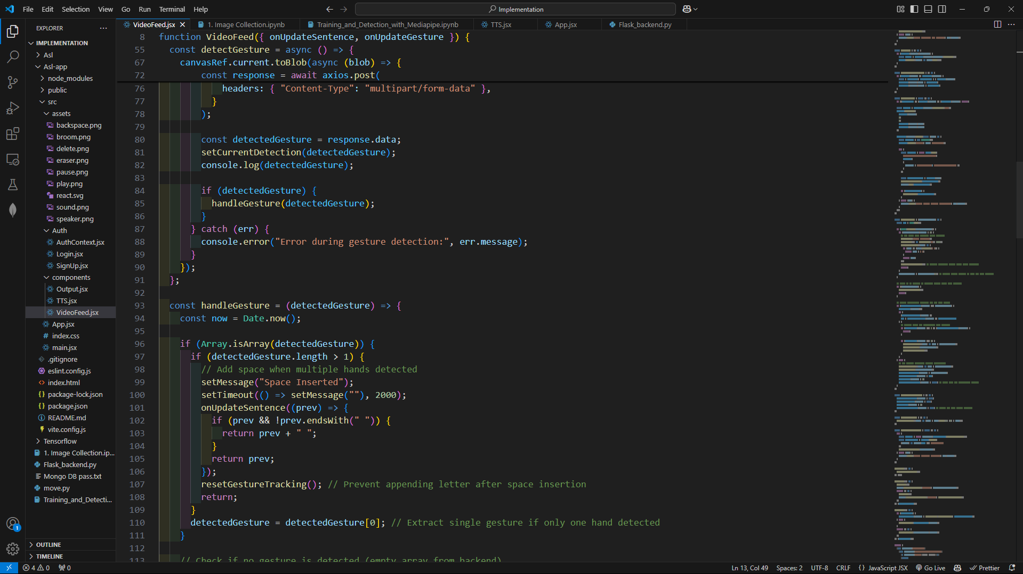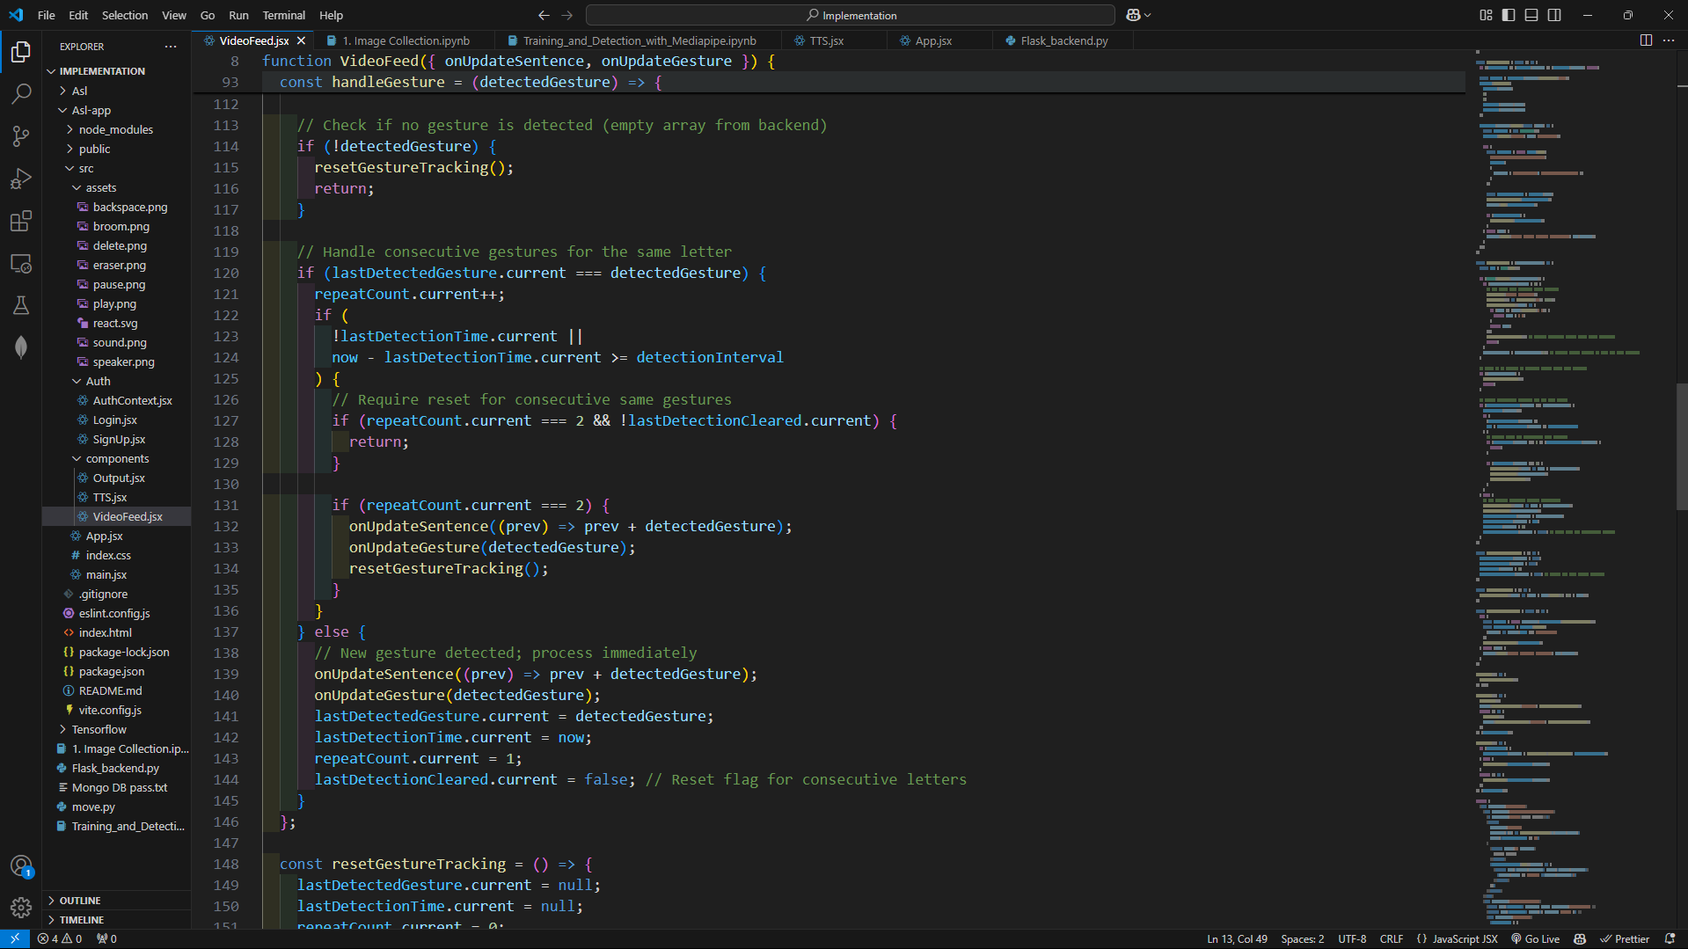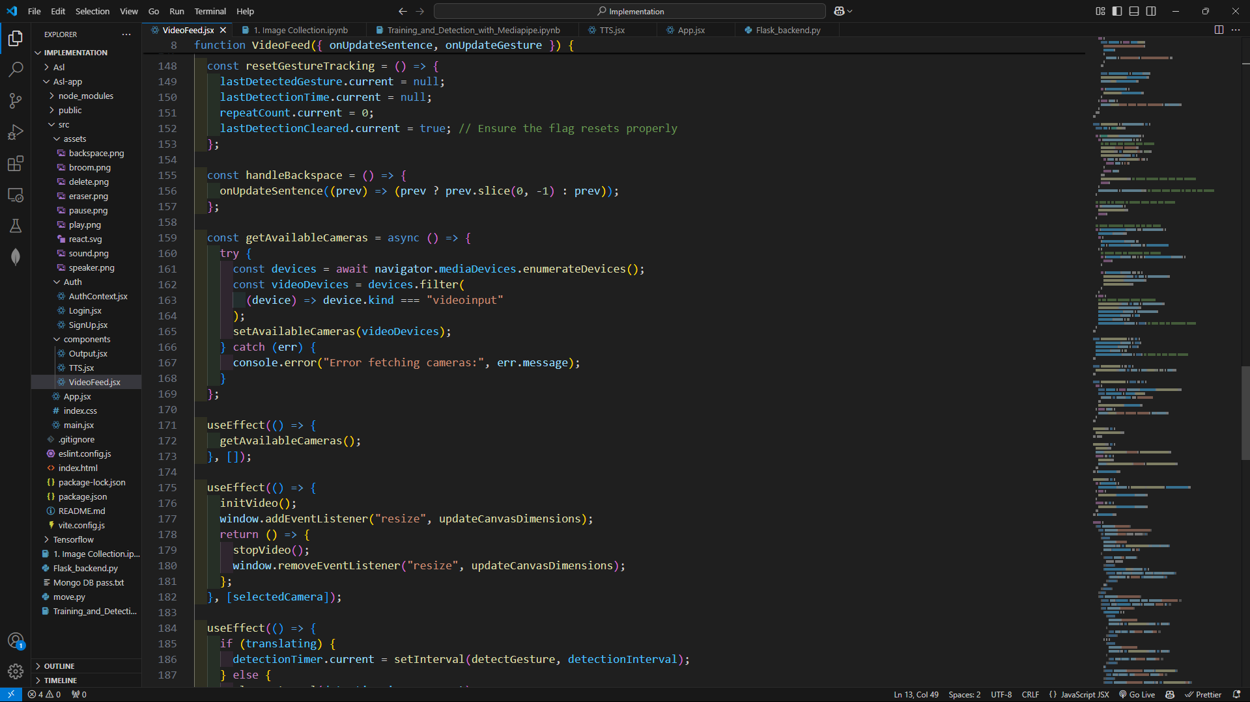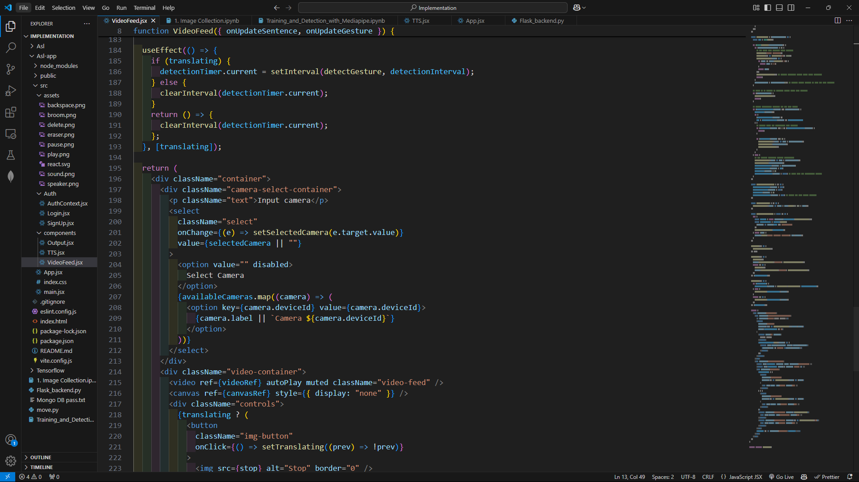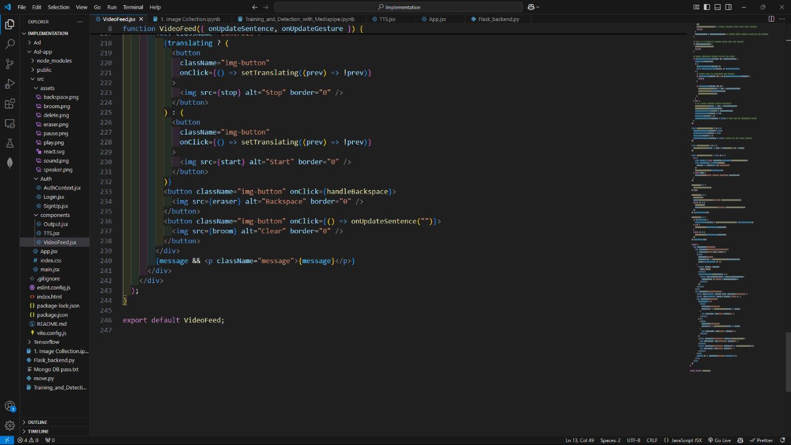

TTS:

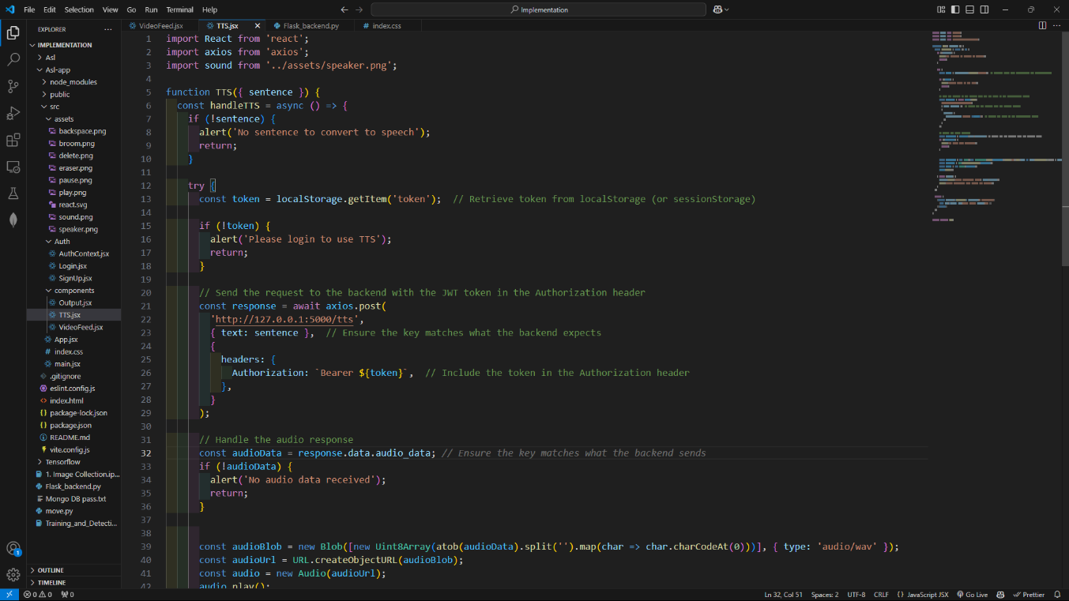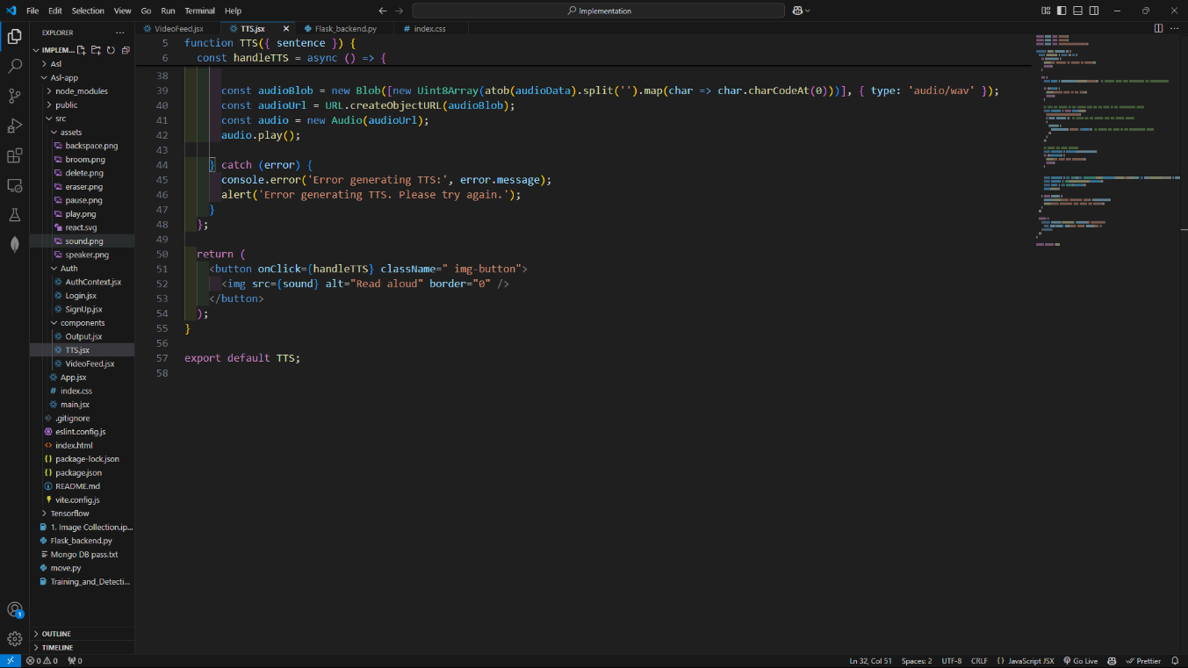

Front-End

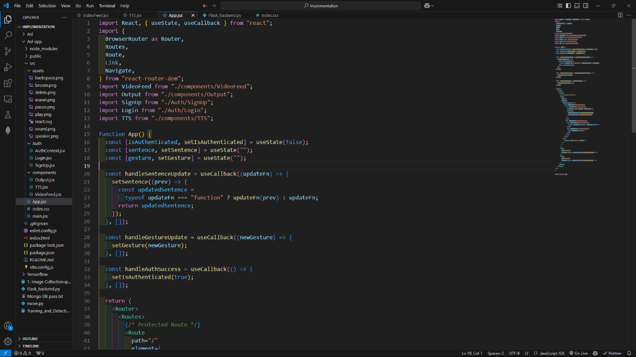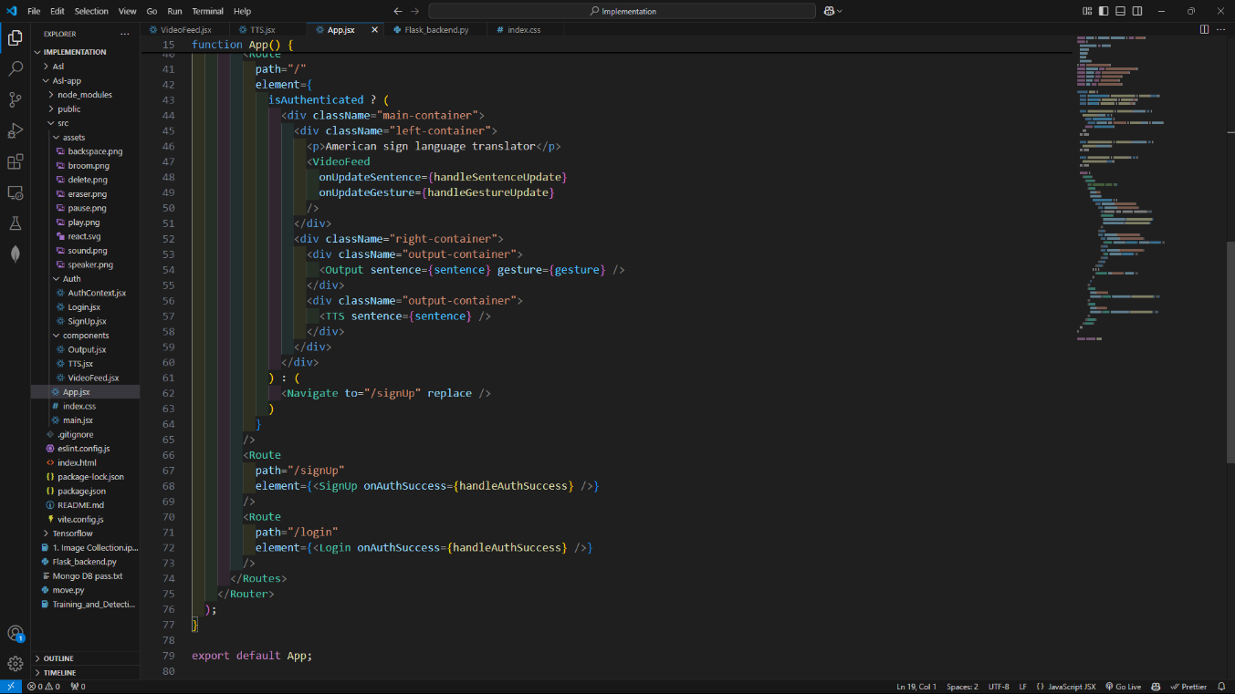

Back-End

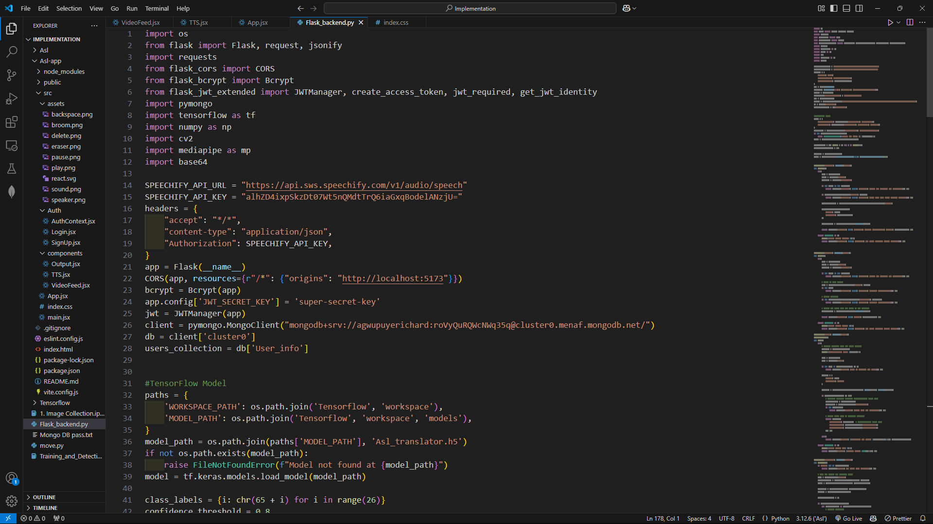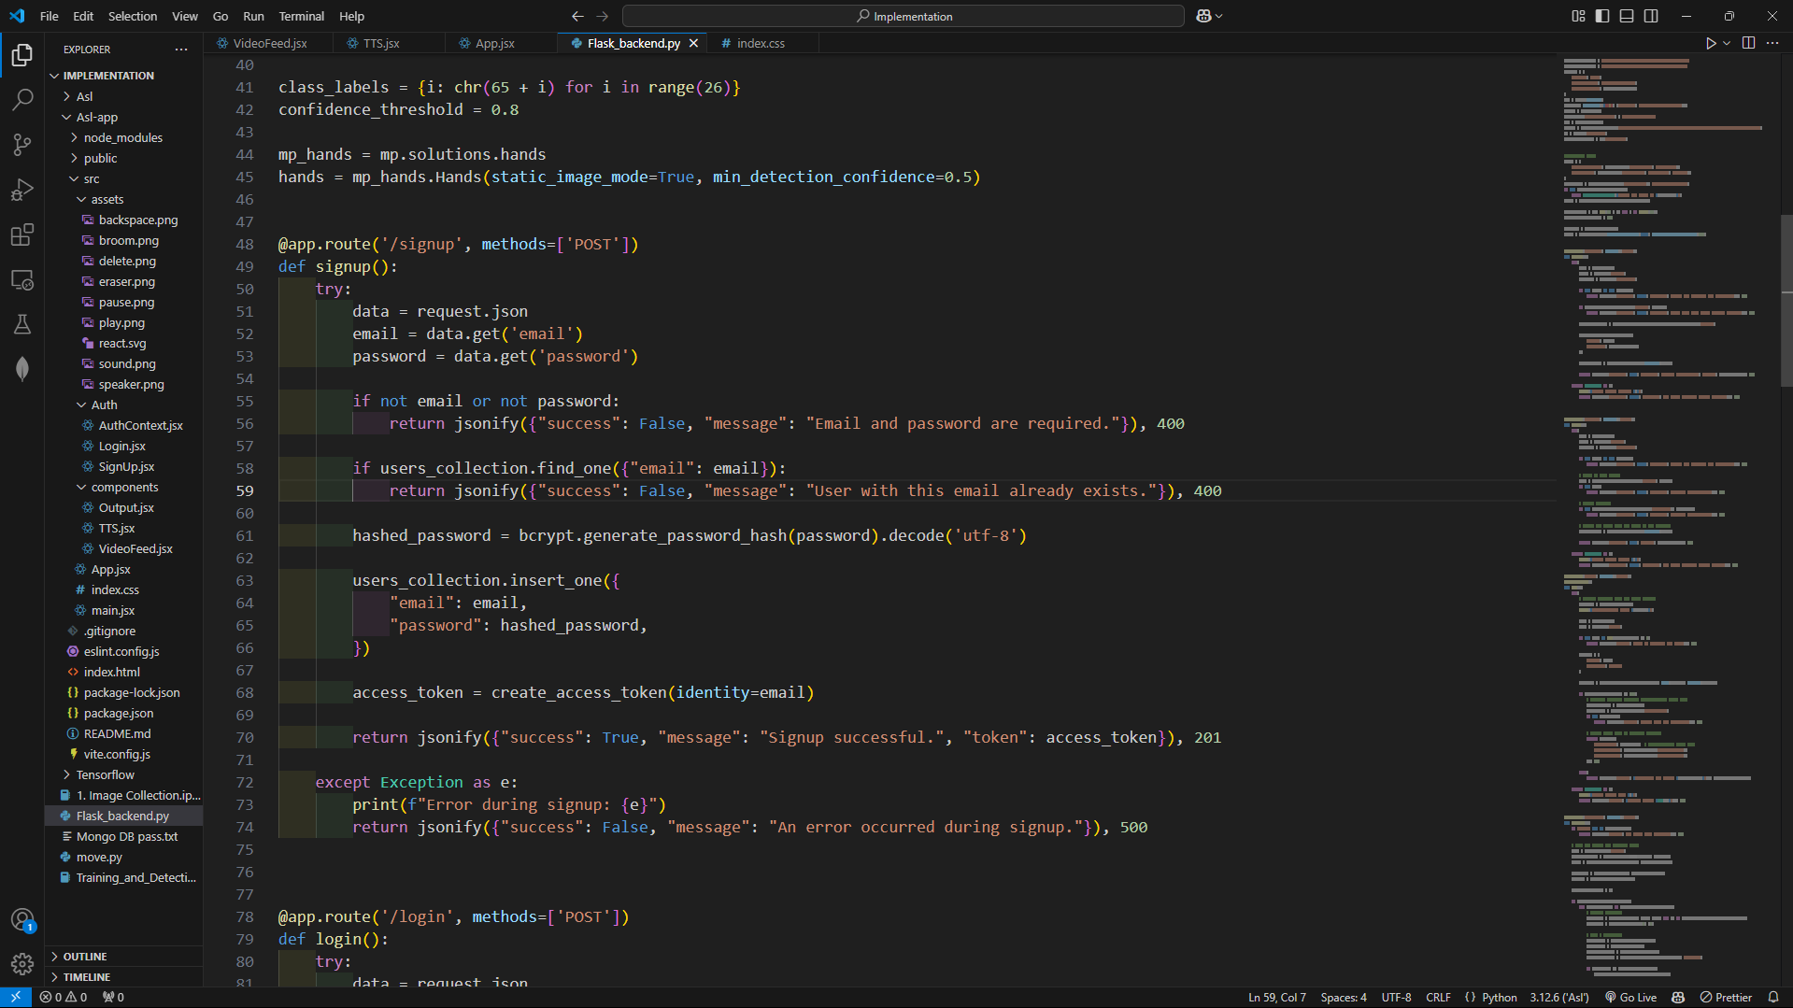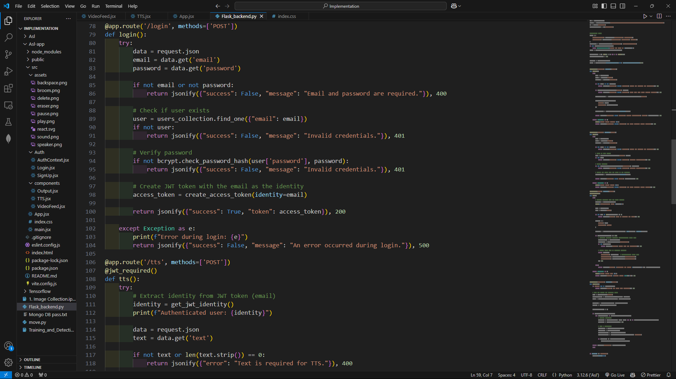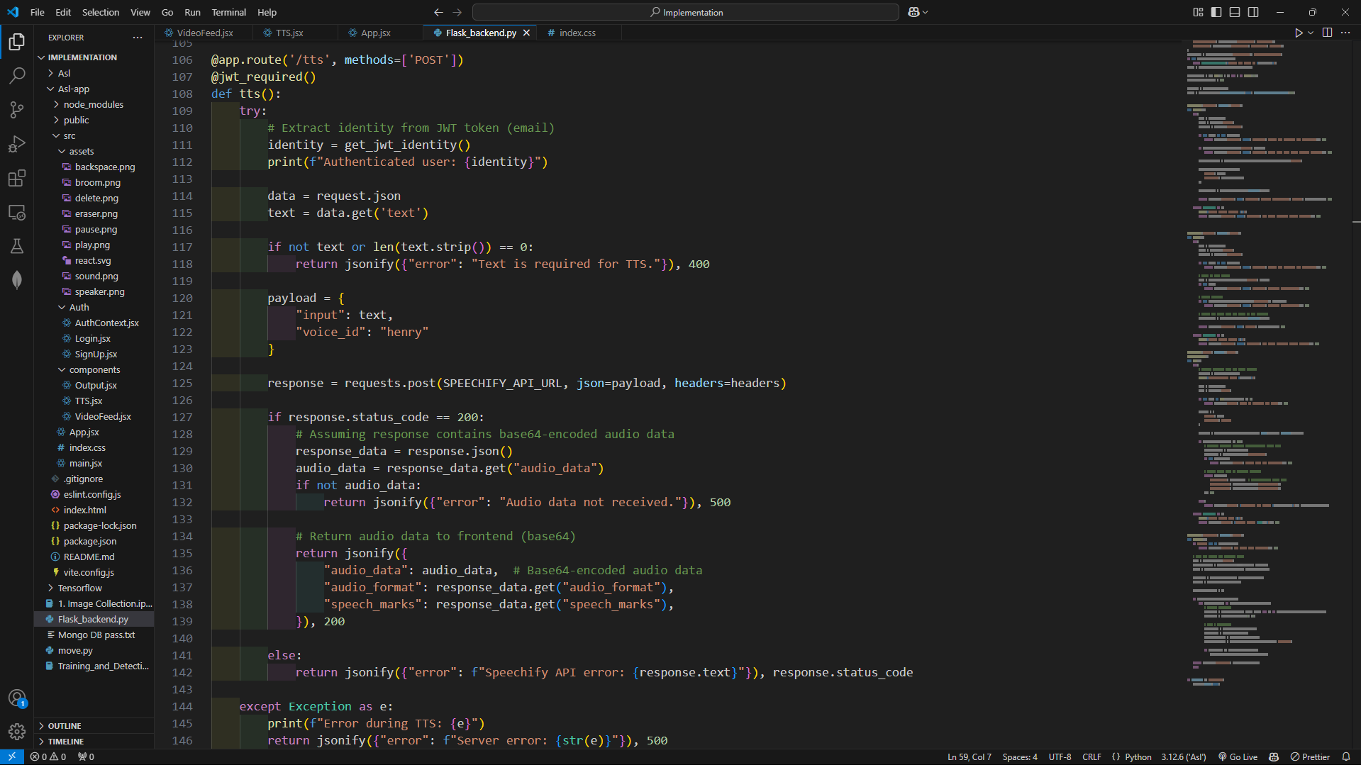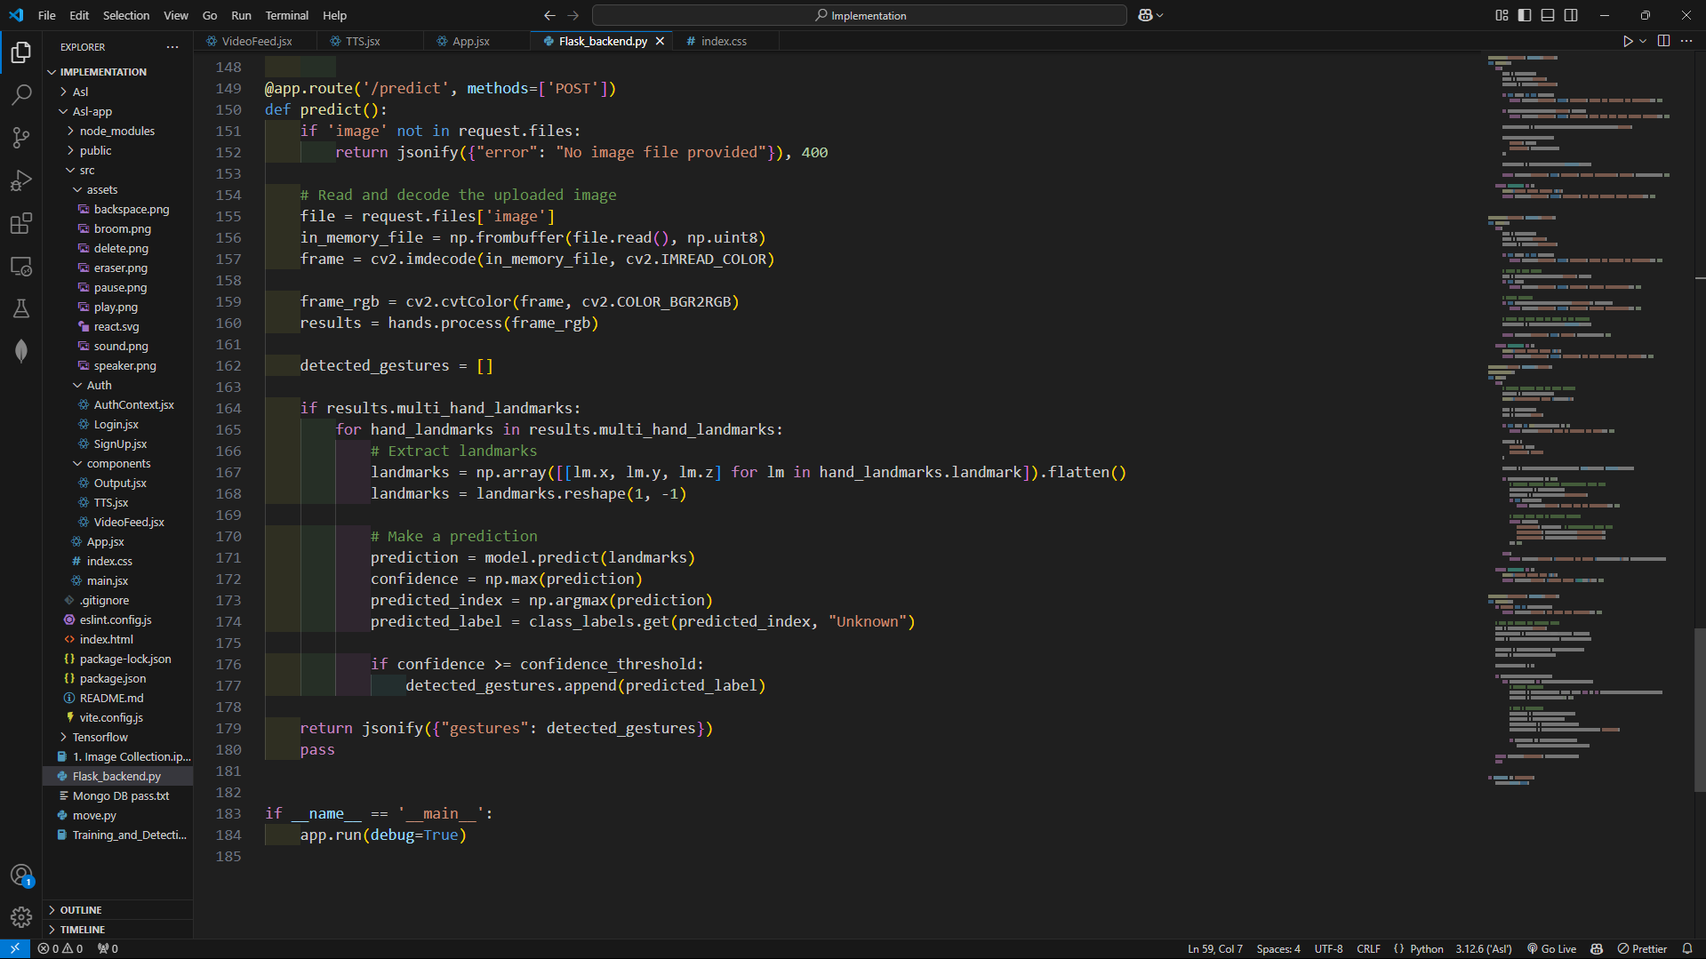

Image Collection:

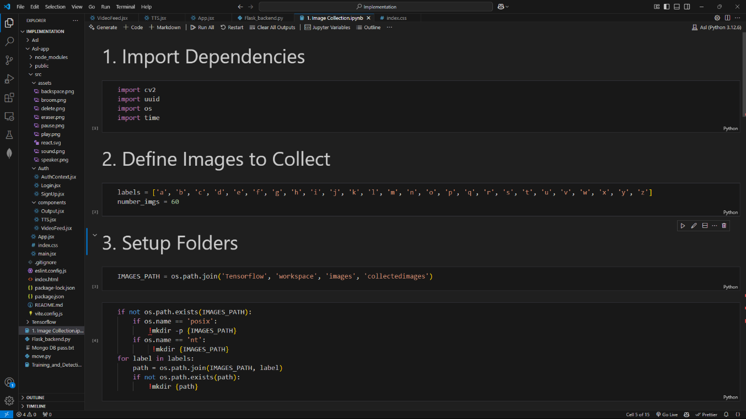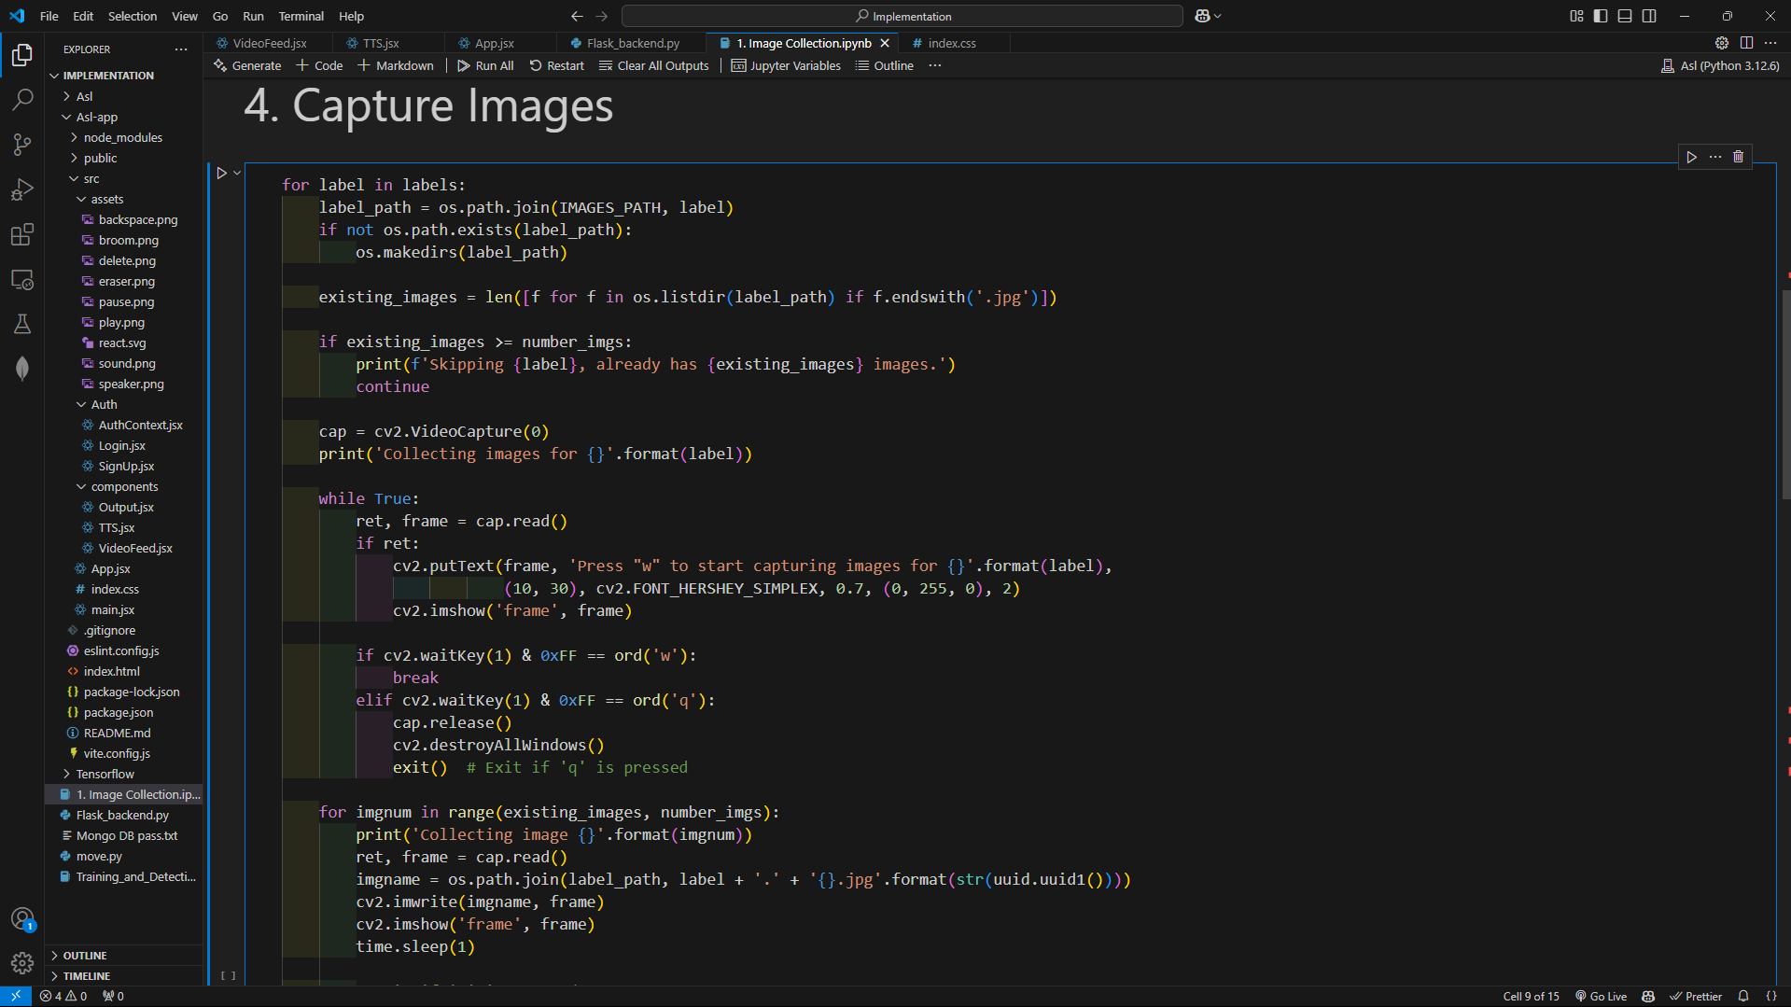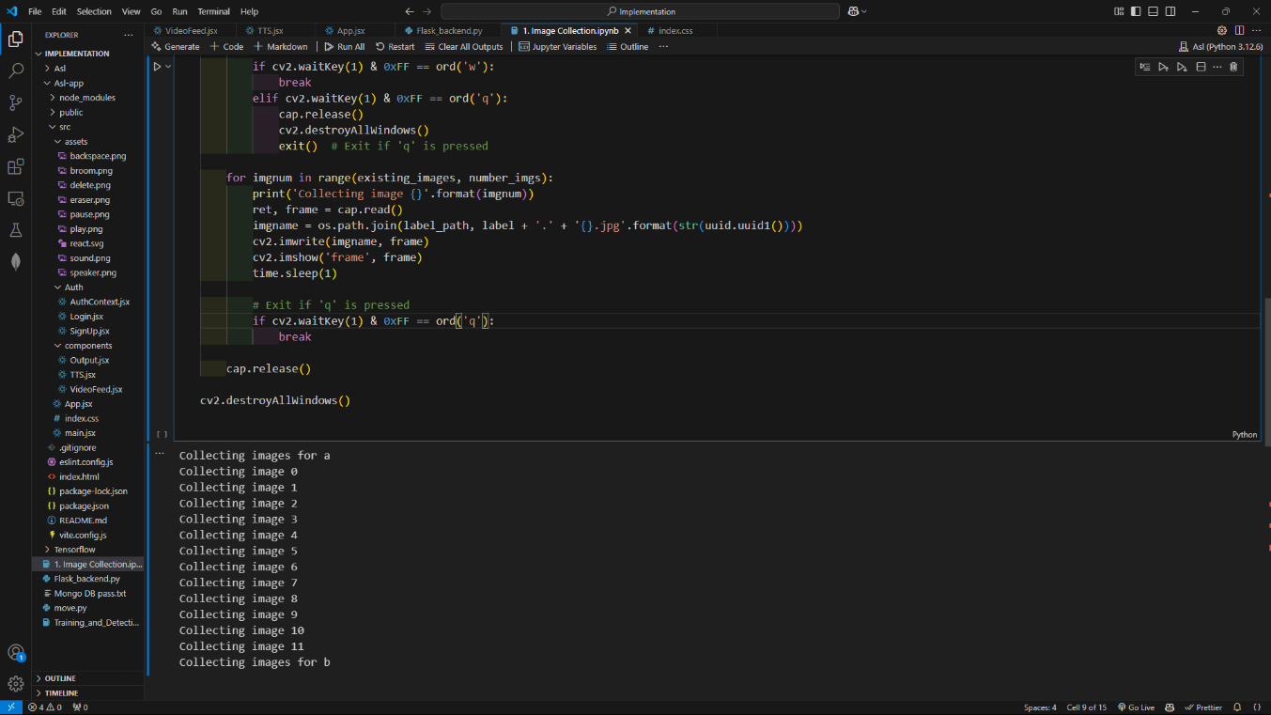

Model Training and testing:

